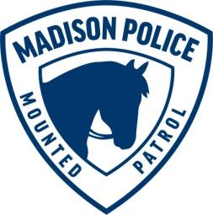
MADISON POLICE DEPARTMENT
Community Corral Appearance Request

The Mounted Patrol Unit conducts appearances Sunday-Thursday during the afternoon and evening hours between April 1st - November 30th.

Appearances are typically 30-40 minutes in length and are informal meet and greets with the officers and horses.

Requests made for appearances outside the City of Madison or on weekends are scheduled on a case-by-case basis as mounted unit staffing allows.

Please complete all of the following information

Date: Click here to enter text.

Time: Click here to enter text.

Address of Community Corral: Click here to enter text.
Contact Person: Click here to enter text.
Contact Person: Click here to enter text.
Phone Number: Click here to enter text.

E-mail Address: Click here to enter text.

Expected number of attendees: Click here to enter text.

Please email completed forms to the Madison Police Mounted Patrol Unit.

Questions regarding the scheduling of an appearance can be directed to the Madison Police Mounted Patrol Unit.

