 | Madison Parks Division  330 E. Lakeside Street  Madison, WI 53715  (608) 266-4711 • cityofmadison.com/parks | 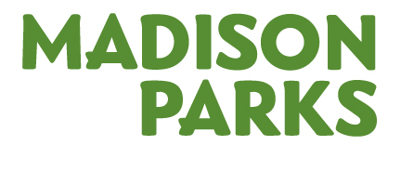

COMMERCIAL SHOOT PARK APPLICATION

Contact Info: Name:
Address:
Email:
Phone:
Phone During Shoot:
Organization/Company:
Type of Shoot: | Commercial |  |  | Still | Catalog
Park Requested:
Area(s) in the Park:
Date(s) Requested:
Rain Date(s) Requested:
Approximate Times:
Anticipated Number of People Involved:
Amplification: | Yes | No | If Yes, time: to

BASIC DESCRIPTION OF SHOOT:

ANY OTHER NOTES OR INFORMATION YOU FEEL WE SHOULD HAVE: SETUP (TENTS, TEMPORARY STRUCTURES, PORTABLE TOILETS, ETC.)

Cost for a Commercial Shoot in a City of Madison Park:
- Full Day: $250
- Half Day: $200

ADDITIONAL INFORMATION:
- If renting a shelter for the shoot, there will be shelter fees also.
- If having amplification or temporary structures, there are fees for those permits.
- Fees must be paid prior to the date of the Commercial Shoot.
- Applicant must agree to follow Madison Parks’ standard conditions as well as any specific conditions determined for the shoot by Madison Parks staff. The conditions will be sent to you prior to the date of the shoot.

