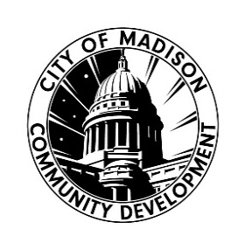
Employment and Career Development Services

2026 Request for Proposal DUE 8/3/26 4:30pm

Application Checklist: Joint/Multi-Agency
APPLICATION CHECKLIST
Please complete the checklist below if you are applying as a JOINT/MULTI-AGENCY ONLY, and are the lead applicant, as you prepare and submit the required application materials for the 2026 Employment and Career Development Services Request for Proposal.
Click the boxes on the right of the list as you complete the items and please submit this along with the required application materials.
If you need assistance related to the content of the application or are unclear about how to respond to any questions, please contact CDD staff: Yolanda Shelton-Morris, Community Resources Manager yshelton-morris@cityofmadison.com or Community Development Specialist Dominic Davis ddavis2@cityofmadison.com. We are committed to assisting interested organizations in understanding and working through this application and funding process.
If you have any questions or concerns that are related to technical aspects of this document, including difficulties with text boxes or auto fill functions, please contact Madeline Bohrod – mbohrod@cityofmadison.com.
Please be sure to read all RFP Guidelines and Application Instructions before you complete this form and submit materials.
Joint/multi-agency checklist of required application materials
LEAD APPLICANT:
☐ Attend a workshop/meet with a CDD staff member by: 6/29/26 4:30PM
☐ Complete and Submit Letter of Intent by: 7/10/26 4:30PM
☐ Complete and Submit Application Part 1- Organization Narrative by: 8/3/26 at 4:30PM
☐ Complete and Submit Application Part 2- Program Narrative(s) by: 8/3/26 at 4:30PM
☐ Complete and Submit Application Part 3- Budget Workbook by: 8/3/26 at 4:30PM
☐ Complete and Submit Budget Narrative by: 8/3/26 at 4:30PM - Required for LEAD Joint/Multi-Agency Applicants ONLY
IF APPLICABLE:
☐ Complete and Submit Fiscal Agent Form by: 8/3/26 at 4:30PM (if applicable)
☐ Complete and Submit Memorandum of Understanding (MOU) by: 8/3/26 at 4:30PM - Joint/Multi-Agency Applications listing any additional joint/partner applicant ONLY (if applicable)

