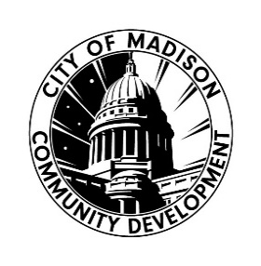

Crisis Intervention and Prevention Services 2025 Request for Proposal DUE 9/22/25 4:30pm Application Checklist: Joint/Multi-Agency

APPLICATION CHECKLIST
Please complete the checklist below if you are applying as a JOINT/MULTI-AGENCY ONLY, and are the lead applicant, as you prepare and submit the required application materials for the 2025 Crisis Intervention and Prevention Services Request for Proposal.
Click the boxes on the right of the list as you complete the items and please submit this along with the required application materials.
If you need assistance related to the content of the application or are unclear about how to respond to any questions, please contact CDD staff: Yolanda Shelton-Morris, Community Resources Manager yshelton-morris@cityofmadison.com or Community Development Specialist Nancy Saíz nsaiz@cityofmadison.com. We are committed to assisting interested organizations in understanding and working through this application and funding process.
If you have any questions or concerns that are related to technical aspects of this document, including difficulties with text boxes or auto fill functions, please contact Nancy Saíz – nsaiz@cityofmadison.com.
Please be sure to read ALL RFP Guidelines and Application Instructions before you complete this form and submit materials.
CHECKLIST OF REQUIRED APPLICATION MATERIALS
LEAD APPLICANT:
☐ Attend RFP workshop on: 8/12/25 2:30-3:30 PM or 8/14/25 10:00-11:00 AM—or--schedule a conversation with City staff prior to: 8/25/25 4:30 PM
☐ Complete and Submit Letter of Intent by: 8/25/25 4:30PM

☐ Complete and Submit Application Part 1- Organization Narrative by: 9/22/25 at 4:30 pm

☐ Complete and Submit Application Part 2- Program Narrative(s) by: 9/22/25 at 4:30 pm

☐ Complete and Submit Application Part 3- Budget Workbook by: 9/22/25 at 4:30 pm
☐ Complete and Submit Budget Narrative by: 9/22/25 at 4:30 pm - Required for LEAD Joint/Multi-Agency Applicants ONLY
IF APPLICABLE:
☐ Complete and Submit Fiscal Agent Form by: 9/22/25 at 4:30 pm (if applicable)

☐ Complete and Submit Memorandum of Understanding (MOU) by: 9/22/25 at 4:30 pm - Joint/Multi-Agency Applications listing any additional joint/partner applicant ONLY (if applicable)

