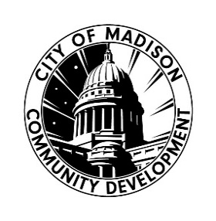

Crisis Intervention and Prevention Services 2025 Request for Proposals DUE 9/22/25 4:30PM

Application Checklist: Single Agency

APPLICATION CHECKLIST
Please complete the checklist below if you are applying as a SINGLE AGENCY ONLY, as you prepare and submit the required application materials for the 2025 Crisis Intervention and Prevention Services Request for Proposal.

Click the boxes on the right of the list as you complete the items. This checklist serves as an additional form to support you through the process of submitting all required materials for the application.
If you need assistance related to the content of the application, or you are unclear about how to respond to any question(s), please contact CDD staff: Nancy Saíz, Community Development Specialist nsaiz@cityofmadison.com or Yolanda Shelton-Morris, Community Resources Manager yshelton-morris@cityofmadison.com. We are committed to assisting interested organizations in understanding and working through this application and funding process.
If you have any questions or concerns that are related to technical aspects of this document, including difficulties with text boxes or auto fill functions, please contact Nancy Saíz – nsaiz@cityofmadison.com
Please be sure to read ALL RFP Guidelines and Application Instructions before you complete this form and submit materials.

CHECKLIST OF REQUIRED APPLICATION MATERIALS
SINGLE APPLICANTS:
☐ Attend RFP workshop on: 8/12/25 2:30-3:30 PM or 8/14/25 10:00-11:00 AM or--schedule a conversation with City staff prior to: 8/25/25 at 4:30 PM
☐ Complete and Submit Letter of Intent by: 8/25/25 at 4:30 PM

☐ Complete and Submit Application Part 1- Organization Narrative by: 9/22/25 at 4:30 PM

☐ Complete and Submit Application Part 2- Program Narrative(s) by: 9/22/25 at 4:30 PM

☐ Complete and Submit Application Part 3- Budget Workbook by: 9/22/25 at 4:30 PM
IF APPLICABLE:

☐ Complete and Submit Fiscal Agent Form by: 9/22/25 at 4:30 PM (if applicable)

