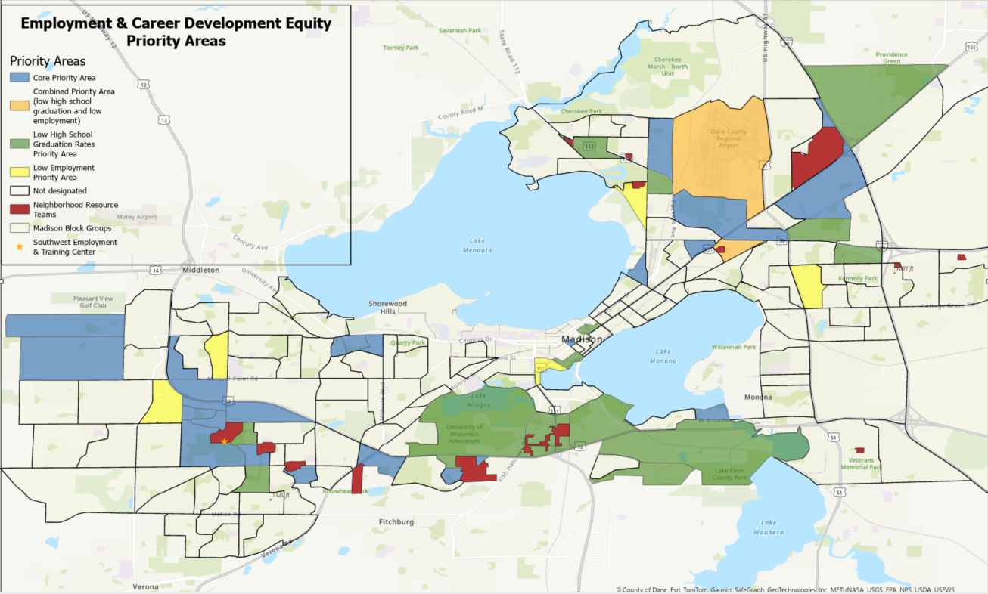
Appendix A
All highlighted areas of the map are considered Employment and Career Development Equity Priority Areas including:
- Core Priority areas (blue): Areas with higher concentrations of BIPOC and low-income adults
- Low High School Priority areas (green): Areas with higher concentrations of BIPOC and low-income adults as well as low high school graduation rates.
- Low Employment Priority areas (yellow): Areas with higher concentrations of BIPOC and low-income adults as well as low employment rates.
- Combined Priority areas (orange): Areas with higher concentrations of BIPOC and low-income adults, low high school graduation rates, and low employment rates.
- Neighborhood Resource Team areas (red): Historically under-resourced areas where City departments and community partners coordinate services and resources around neighborhood priorities.

