Kronos Q&A Session #3 – Facilities Management, Finance, and City Engineer
June 21, 2023

- How do I show less of the top and bottom sections of Kronos so I can see more of my timesheet?
- Click the “Maximize” icon to maximize your timesheet view.

You can also click and drag expansion bar (highlighted below) or left click expansion bar to expand/ minimize.
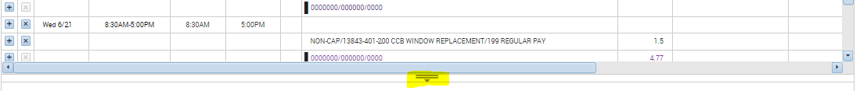

- I had 4 hours of approved vacation. My work day ended up starting earlier and ending later than I had anticipated when I requested vacation so I don’t need to use all 4 hours of approved vacation that is still showing on my timesheet. How do I adjust my vacation?
- Only a payroll team member can override approved time off. Please email Jennifer or Kong and copy the supervisor who approves your timesheet.

- Every time I enter something in my timesheet, the screen jumps back up to first line and then I have to scroll down. How can I stop this from occurring?
- This appears to be an issue affecting one user. Kong will work with user to get this corrected.

- Can we increase the time before inactivity logs me out of Kronos?
- We will review options in Kronos and consider security implications and get back to everyone on this request.

- Is it possible to have Kronos display the Manager’s Workspace upon log in?
- There are options for group display profiles in Kronos. Kong will research this issue after Kronos is fully implemented with CCB staff.

- Can Kronos hold off on recalculating totals as each duration is entered so we can add lines with activities and enter time throughout the day?
- We don’t know the answer to this question but will contact Kronos to find out.

- I worked on a holiday. How do I enter my time worked?
- You have 2 options. First option, you can use the “Record Timestamp” button. This will automatically create a new row for the holiday and enter your in and out times. Second option, you can click the plus next to the date of the holiday to create a new line and manually enter your start and end work times.

- What project or org code should I use for my time off?
- You do not need to enter a project or org code for your time off. Paid leave is coded behind the scenes based on the allocation code assigned to you in Munis.
- How do I approve my timesheet?
- Click on “Approve Timecard” and select “Approve Timecard” from the drop down.
Once you’ve approved your timesheet you can no longer edit it. If you need to edit your timesheet after approving, you will need to “Remove Timecard Approval”. Then once your edits are completed approve your timecard again.

- What should we be looking for before we approve our timesheets?
- Verify that your regular pay and any paid time off total 77.5 hours. There should also be no numbers in the variance column. If there are that means you have under (or over) allocated hours to project and/or org codes.
- Should total actual hours for each day match the total allocated?
- No – “Total Actual” equals your total hours worked PLUS your unpaid lunch period. “Total Allocated” is your total hours worked and does not include your unpaid lunch period.
- Can pay code be put in the Pay Code column instead being part of the Activity description?
- No – the Activity description is from Munis.
- Is there a summary that shows how many hours I have in each pay code?
- As of right now Kronos doesn’t have a summary for activities employees. This was explored by Kong and Kronos back in February 2023 and they stated this is possible. There is, however, a report that user with a manager license can run. Kong will contact Kronos if this is possible to give access to all employees.
- Is there a way for Kronos to display my projected remaining accrual balances based on time off requests I’ve submitted for future dates?
- “Accruals” displays the following information for each category:
- Accrual Available Balance – If you do not have a date selected in your timesheet this will display the amount of paid leave available for each category at the start of the current pay period. This information is updated from Munis every 2 weeks after payroll posts.
If you are working in your timecard the balance displayed will be for the date you have selected. If you have approved paid leave during the current pay period you can see this number change as you move from a date prior to your approved paid leave and to the date of paid leave or later.
- Accrual Reporting Period – This is the current calendar year.
- Accrual Opening Balance – This shows the amount of paid leave you had at the beginning of the year. This information is provided by Munis.
- Accrual Ending Balance – This shows the projected amount of paid leave you have available after all approved requests (including future) are deducted.
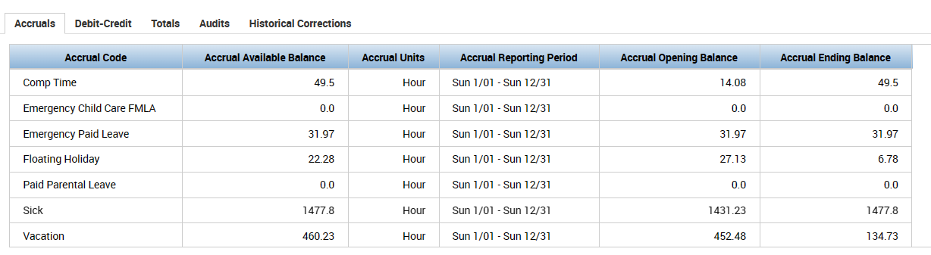
To view your paid leave balance during the current pay period select the date as of which you want to know your balance. Your current available balance will display in the

In the example below, the user has used floating holiday on Thursday, June 15. By selecting Wed., June 14 in the timesheet the Accrual tab displays Floating Holiday as of that date.
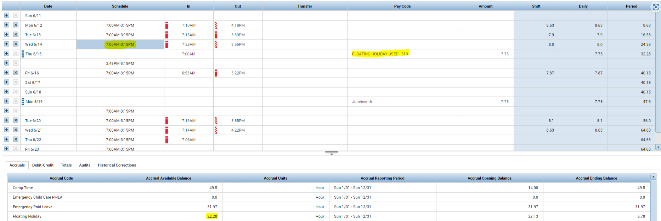
- If you use paid leave during the current payroll period you can view your remaining accrual balance by clicking the day before and after. This number will change to show what the employee has after each paid leave. For approved requests out in the future you future requests that has been approve, employees can reference to the Accrual Ending Balance as this will project the amount of hours left for each paid leave. Fore pending requests, Kong will work with Kronos to see if this can be possible to add a pending approval request to reflect the projected remaining accrual balances.
- Selected the day (6/14/23/ before the approved Paid Leave in Timesheet and look at Accruals tab to see balances.

- Selected Day After in Time sheet to see the changes in Accrual Available Balance:

- Accrual Ending Balance shows amount left if there was any future approved requests. On 6/16/23 EE has 14.53 of Floating Holiday but in the future has only 6.78 left as there was some FH approved to be used.

