YOU’RE INVITED: CITY OF MADISON PUBLIC INFORMATION MEETING
PROJECT NAME: S. FRANKLIN AVE, RIDGE ROAD, AND SYLVAN AVE RECONSTRUCTION
TIME/DATE/LOCATION: 6:30 PM, July 20, 2026, Virtual Zoom Meeting
CONTACT: Andrew Zwieg, P.E., Project Manager, 608-266-9219 or azwieg@cityofmadison.com
PROJECT/REGISTRATION LINK (REGISTRATION REQUIRED):
www.cityofmadison.com/engineering/projects/south-franklin-ave-ridge-road-sylvan-ave-reconstruction
The City of Madison is planning a 2027 reconstruction project on S. Franklin Ave (Speedway Rd to Regent St), Ridge Rd (Glenway St to S. Franklin Ave), and Sylvan Ave (West End to S. Franklin Ave).
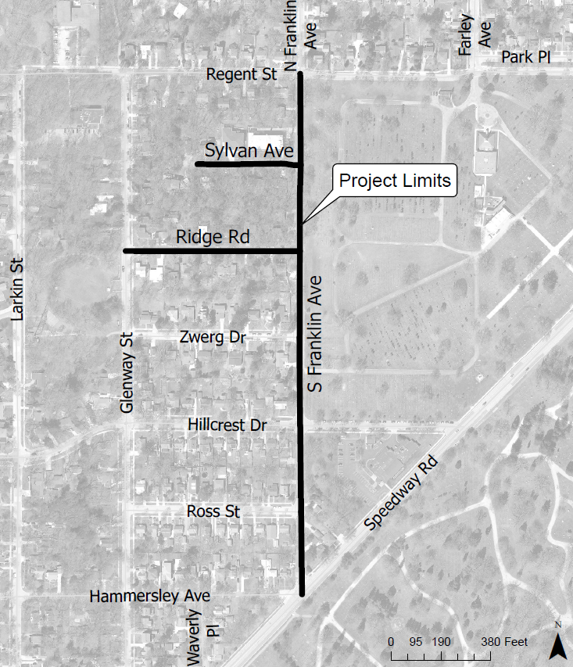
The public is encouraged to attend to learn about the project scope, street design, utility installation, assessments, construction timeline, and how the project will impact residents & businesses on or around the project limits.
To request interpretation, translation or a disability-related accommodation at no cost to you, contact 608-266-9219 or azwieg@cityofmadison.com.
Para solicitar interpretación, traducción o una adaptación especial relacionada con alguna discapacidad sin costo alguno para usted, comuníquese al 608-266-9219 o al correo azwieg@cityofmadison.com.
Scan the QR code with your phone’s camera to go directly to the website

如需免費提供口譯、筆譯或殘疾相關的便利服務，請聯系 608-266-9219 或 azwieg@cityofmadison.com.
Koj muaj txoj cai tau txais kev txhais lus, kev pes lus los sis kev pab cuam txhawm rau kev tsis taus uas tsis muaj nqi rau koj: Xav paub ntxiv tiv tauj rau 608-266-9219 los sis azwieg@cityofmadison.com.
YOU’RE INVITED: CITY OF MADISON PUBLIC INFORMATION MEETING
PROJECT NAME: S. FRANKLIN AVE, RIDGE ROAD, AND SYLVAN AVE RECONSTRUCTION
TIME/DATE/LOCATION: 6:30 PM, July 20, 2026, Virtual Zoom Meeting
CONTACT: Andrew Zwieg, P.E., Project Manager, 608-266-9219 or azwieg@cityofmadison.com
PROJECT/REGISTRATION LINK (REGISTRATION REQUIRED):
www.cityofmadison.com/engineering/projects/south-franklin-ave-ridge-road-sylvan-ave-reconstruction
The City of Madison is planning a 2027 reconstruction project on S. Franklin Ave (Speedway Rd to Regent St), Ridge Rd (Glenway St to S. Franklin Ave), and Sylvan Ave (West End to S. Franklin Ave).
The public is encouraged to attend to learn about the project scope, street design, utility installation, assessments, construction timeline, and how the project will impact residents & businesses on or around the project limits.
To request interpretation, translation or a disability-related accommodation at no cost to you, contact 608-266-9219 or azwieg@cityofmadison.com.
Para solicitar interpretación, traducción o una adaptación especial relacionada con alguna discapacidad sin costo alguno para usted, comuníquese al 608-266-9219 o al correo azwieg@cityofmadison.com.
如需免費提供口譯、筆譯或殘疾相關的便利服務，請聯系608-266-9219 或 azwieg@cityofmadison.com.
Scan the QR code with your phone’s camera to go directly to the website
Koj muaj txoj cai tau txais kev txhais lus, kev pes lus los sis kev pab cuam txhawm rau kev tsis taus uas tsis muaj nqi rau koj: Xav paub ntxiv tiv tauj rau 608-266-9219 los sis azwieg@cityofmadison.com.

EDIT NOTES
- DO NOT remove or attempt to move the map and QR code boxes.
  - Copy in image/QR, then set to “in front of text” and align to boxes.
- Please do not use text justification.
- When complete, please send to EN Admin as a Word document.

