2027 Cost to Continue Instructions

Operating Budget Cost to Continue (C2C)
Cost to Continue (C2C) is the first step of developing the city’s operating budget. The purpose is to systematically identify projected changes in the budget and develop a baseline estimate of how much it will cost the City to provide the same level of service in the upcoming year. This activity takes place in the spring, prior to the June budget kick-off.
- Role of Agency Staff: Department/ Division heads and budget contacts are responsible for completing the agency C2C Excel Worksheet.
- Role of Budget Staff: Analysts complete an independent analysis of agency budgets and meet with agency staff to review estimates. In addition, analysts account for citywide adjustments (e.g. salary and benefits adjustments).

C2C Timeline for 2027 Budget (dates in 2026)
- March 30 – April 10: Agency staff and budget analysts independently complete C2C Excel file
- April 13 – 24: Agency staff and budget analysts meet to discuss and finalize C2C
- April 27 – May 8: Budget team compiles agency-level files, develops a citywide C2C, and begins planning for Agency Request phase

Criteria for C2C
The purpose of Cost to Continue is to identify how much it will cost to provide the same level of service in the upcoming year. C2C proposals must meet the following criteria:
- Base Budget: C2C assumes providing the same level of service, not an increase or change to services. Proposed adjustments must be in your 2026 base budget.
Note: There may be limited exceptions to add items not in the 2026 base, such as biennial costs (e.g. elections), costs related to Town attachments, or costs related to an existing long-range plan. Contact your budget analyst if you have questions.
- Planned and Unavoidable: This refers to costs that you cannot change, such as increases to multi-year contracts, increases in utility rates, etc.
Including an expense in C2C does not guarantee it will be included in your base budget. The Budget Team will evaluate all agency C2C items to determine whether it is cost to continue or if it should be part of the agency request.

How to Complete the C2C form
C2C is a simple Excel form. For each section, read the guiding questions and complete the information as thoroughly as possible.
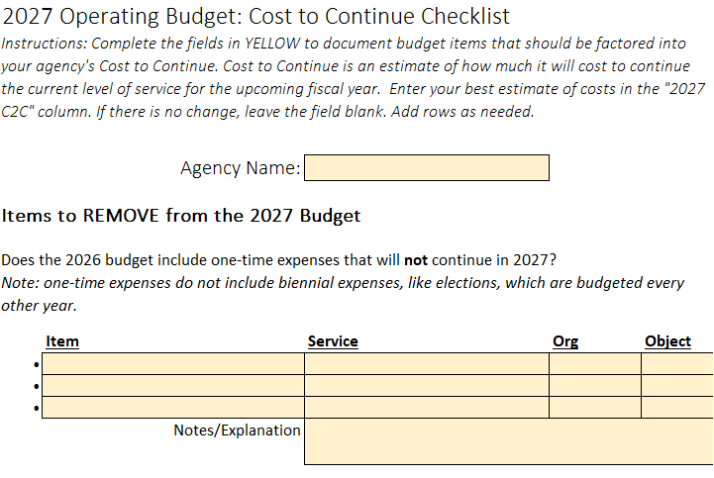
- If you do not know the org/ object for an item, that is okay. Your analyst can help you identify that when you meet.
- You can skip sections that are not relevant.
- You can add tabs with additional analysis or send your budget analyst other supporting documents if needed

Tips for Completing C2C

DO
- Review your 2026 adopted budget. Does your budget include one-time expenses that should be removed? Partial year commitments that will be annualized?
- Review how you ended 2025. The C2C form has a “Budget to Actuals” Tab with a Munis Cube that can help review prior year expenditures. Were you over/under on specific items? Do you expect these trends to continue? Pay special attention to revenues, supplies, and purchased services.
- Only include changes specific to your department. Citywide changes like cost of living increases and ID Charges will be handled centrally.
- Provide supporting documentation to justify changes to C2C, especially cost increases.

DON’T
- Don’t factor in standard personnel costs, like COLAs or health care costs.
- Don’t adjust centrally budgeted items like Fleet Charges, Insurance, and Workers Comp. Contact your analyst if you're not sure what's centrally budgeted.
- Don’t add in ongoing costs that were fully funded in the 2026 Budget; these expenses will already be accounted for in C2C.

Future Issues: Results Madison and Long-Range Planning
We want to make you aware of two items that will be introduced as part of the budget request in June. You do not need to do anything for C2C but should start thinking ahead.

Results Madison Indicators
Background: As part of Results Madison, all agencies have started or completed a data engagement to identify service indicators related to their activities.
Agency Request: Agencies will be expected to incorporate service indicator data in their budget request. If your agency completed the data engagement, you will also be expected to present 2-3 indicators in the budget document. These indicators should reflect your agency’s work effort/ outputs/ outcomes, be understandable to a public audience, and be related to activities described in your budgeted services. Additional guidance on what makes a good indicator will be shared as part of the agency request or earlier.
What can you do now? Follow guidance from the Data Team on updating your service indicator data and/or completing your data engagement. You can also review your indicators to begin identifying potential items to include in the budget. Contact datateam@cityofmadison.com if you need assistance accessing your service indicators.

Long Range Planning
Background: The 2026 Adopted Operating Budget includes a five-year plan as a roadmap for future budgets. This plan will be updated for the 2027 budget. Currently, our model is based on citywide assumptions and does not capture the needs of individual agencies.
Agency Request: As part of the operating budget request, you will be able to identify future operating costs for major projects or initiatives that are planned from 2028 – 2032. The format is TBD, but will be a simple template to capture basic information about costs.
The scope of the long-range plan will be limited to operating costs related to known projects. For example, costs to operate a new facility that will come online in the next five years, software moving to the cloud, implementing recommendations from a strategic plan. At this time, we are not planning to capture general staffing or operational needs. These general costs may be addressed in future phases of long-range planning.
What can you do now? As you’re completing C2C, think about future projects and budget needs. Begin talking to staff about needs so you are ready to complete this request in June.

