

Direct Deposit Authorization Agreement

Vendor #: (For City Ofc Use only)

Vendor Information
Vendor Type: Individual Partnership Corporation
Vendor Tax ID/Soc. Sec #:
Vendor/Individual Name:
Address:
City: State: Zip Code:
Email: Phone:

NEW ACCOUNT:
I hereby authorize the City of Madison and the Financial Institution named below to deposit money due to me by electronic transfer to my account. If amounts to which I am not entitled are deposited into my account, I authorize the City of Madison to direct my Financial Institution to return them, upon proper notice to me. In the event my designated account is closed or contains an insufficient balance to allow a deduction for amounts deposited in error, I agree that the City of Madison may withhold any amounts owing to me until such amount is repaid.

Account Type
Name of Financial Institute:
Transit/Routing #: Account #:
Checking Savings

PREVIOUS ACCOUNT:
If this request is changing banking information, please provide the previous account information.

Account Type
Name of Financial Institute:
Transit/Routing #: Account #:
Checking Savings
This authority is to remain in full force and effect until the City of Madison has received written notification from me on its termination in such time and in such manner as to afford the City of Madison a reasonable time to act. This authorization may be revoked at any time by the City of Madison. I understand that, due to circumstances that are beyond the City’s control, there may be instances that may delay this deposit.
Authorized Signature Date

Printed Name of Signer
Required for bank account verification (select one and attach the corresponding document):
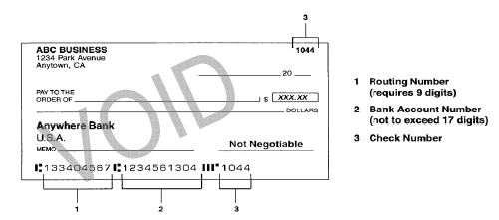
Voided Blank Check Picture of Check Verification Letter from banking institution.

