
Finance Department

Purchasing Services
David P. Schmiedicke, Director
City-County Building, Room 406
210 Martin Luther King, Jr. Blvd.
Madison, WI 53703
Phone: (608) 266-4521 | Fax: (608) 267-5948
purchasing@cityofmadison.com
cityofmadison.com/finance/purchasing

City of Madison Vendor:

The City of Madison is setting your business up as a new vendor or updating your information in our vendor database. We are asking that a representative from your business complete these steps:

Step 1 - Mandatory
Complete the enclosed W-9 form.

Step 2 - Mandatory
The City is making payments via Electronic Funds Transfer (EFT). This is a direct deposit into your bank. This method of payment is more efficient and may allow quicker access to your funds and eliminate lost or delayed paper checks due to mail service. Direct Deposit is the City of Madison’s preferred payment method. If you agree to receive payments by EFT direct deposit, please fill out the separate Direct Deposit Authorization Agreement Form included with this letter, and do NOT fill out the section below. Then go to Step 3.

Only fill out this section if you wish to receive a paper check instead of direct deposit:

Payee Name:
Address of Payment:
Phone Number:
Fax:
Email:
Contact Person:

Business Name:

Step 3 – Optional – Are you a Targeted Business Enterprise?
The City of Madison’s Targeted Business Enterprise (TBE) program ensures that small, minority & women owned businesses have opportunities to compete for City contracts and procurement.

This step is optional - if you choose, please check any of the boxes that apply to your business, and include this when you return this letter, your W-9, and Direct Deposit Agreement.

My business qualifies as (check all that apply):

Small Business Enterprise (SBE) - an independently owned and controlled business with annual gross receipts of $4 million or less when averaged over the past 3 years, and a maximum personal net worth of $1.32 million dollars.

Minority Business Enterprise (MBE) - an independent business 51% or more owned and controlled by a member of one of the following racial/ethnic groups:
African American/Black
Asian or Pacific Islander
American Indian or Alaskan Native
Hispanic
Other (example: multi-racial)

Woman Business Enterprise (WBE) - an independent business 51% or more owned and controlled by women.

Disadvantaged Business Enterprise (DBE) - an independent business 51% or more owned and controlled by socially and economically disadvantaged individuals. Size restrictions as regulated by the U.S. Small Business Administration in 13 CFR apply.

Section 3 Business Concern - must meet 1 of the following in the last 6 months:
- at least 51% owned and controlled by low income or very low income persons;
- over 75% of labor hours performed for the business over the prior 3-month period are performed by Section 3 Workers; or
- at least 51% owned and controlled by current public housing or Section 8 residents.

If you checked any of these boxes, you can be certified through the City’s Targeted Business Enterprise Program. Please send an email with your business name, and which boxes you checked to: targetedbusinessenterprise@cityofmadison.com

In addition to helping you compete for City contracts; this program acts as a form of free marketing and provides government vetting for your business.

No payment can be made until the required Form W-9 and the Direct Deposit Authorization Form (enclosed) OR Vendor Information (on page 1 of this letter) have been returned to the City Finance Department.

Please email to purchasing@cityofmadison.com, or mail the forms to:

City of Madison Finance Dept
Attn: Purchasing
210 Martin Luther King, Jr Blvd, Rm 406
Madison, Wi 53703

Thank you for providing the required information.
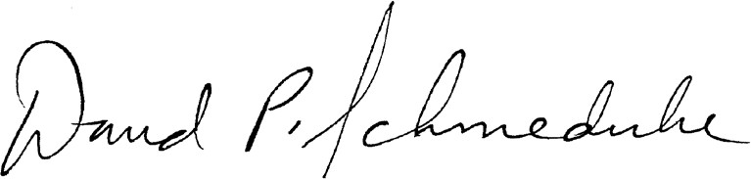

David P. Schmiedicke
Finance Director

