

**Eventbrite for Learning Partners**

**About Learning Partners Permissions in Eventbrite**

As a Learning Partner, you will have access to additional functions that our previous systems just didn’t provide. This will allow you to complete basic functions that we’ve always needed to manage (ex. Tracking registrations and taking attendance) and expand the ease and tracking for functions that have always been . . . shall we say, “challenging” or downright impossible using other systems.

Contents

Permissions in Eventbrite 2

Pre-Course Communications 3

View Registrations 4

Manage the Waitlist 5

Take Attendance 6

Post-Course Communications 7

# Permissions in Eventbrite

When you completed your Course Planning Form to build out the course, we asked for your City of Madison Eventbrite login information. Because you shared that info with us, we provided you with a set of permissions to behind-the-scenes features that standard users do not have access to. This keeps our data safe and sound, compliant with City of Madison IT security standards, and ensuring that things are run in a consistent manner.

**Open and Accept Permissions Request Email**

As a part of your course proofing process, you will have received an email message from Eventbrite that requires your acceptance of the Learning Partners Role. Accept the permissions and follow instructions to access your course pages.

**Manage My Events**

1. Log in to Eventbrite using your City of Madison email address and login information.

*Tip: Bookmark Eventbrite and if appropriate, elect to have your computer remember your login information for easy entry into your courses in the future*

1. If you are not immediately taken to the Manage My Events page,

Navigate to the upper right corner of the system and in the black menu bar, you will see your email address. Click on the drop down to the right of your email to see your Account information

1. Click Manage My Events to be taken to your list of permissioned events.

**Not Seeing Your Event Listed?**

That’s likely a miss on OD’s part. Simply contact us via [OrganizationalDevelopment@cityofmadison.com](mailto:OrganizationalDevelopment@cityofmadison.com)

# Pre-Course Communications

* When: Confirmation Email at point of sale, Reminders 2 days before, 2 hours before, and 10 minutes before start
* Who: [Autogenerated by Eventbrite] to registrants

NOTE: only 1 email is generated if there are multiple registrations on 1 form

* How: [Requires successful Course Set-up in Eventbrite]
* Why: To confirm registrations and remind participants of upcoming courses.
* Where: Eventbrite > Manage My Events > Emails to Attendees

**The short story:** Pre-Course Communications are automated by Eventbrite. If you would like to adjust any of your Pre-Course Communications, you may do so any time before the course using the Emails to Attendees function. If you’d like assistance, please contact OD and we’d be glad to support you!

**Confirmation Emails** are automated within Eventbrite to be sent immediately upon registration.

SUBJECT: Order Confirmation for <<COURSE NAME>>

TEXT: <<REGISTRANT NAME>>, you’ve got tickets!

This event will be hosted online. Check the event page for all the information you need to join.

How to Join

[View the Event]

* TIcket number and price
* Date, Time
* Add to Calendar (Google, Outlook, iCal, Yahoo)
* Location: Online Event (participants can click on event information and get Zoom link)
* Eventbrite required language
* Order Summary (including View and Manage Your Order Online)
* Contact the Organizer link

**Reminder Email/s** are configured within Eventbrite and default send times are:

* 2 days before event - SUBJECT LINE: Reminder for <<COURSE NAME>>
* 2 hours before event – SUBJECT LINE: Starting in 2 Hours: <<COURSE NAME>>
* 10 minutes before event – SUBJECT LINE: Starting Now! <<COURSE NAME>>

TEXT: Your event, <<COURSE NAME>> is happening soon.

How to Join

[View the Event]

* Zoom Meeting information
* Date, Time
* Add to Calendar (Google, Outlook, iCal, Yahoo)
* Eventbrite required language
* Contact the Organizer link

(Optional)

* Information about Prework or other prerequisite activities
* Links to handouts, slides, or other in-session resources on Course Registration webpage
* Pre-course contact information

*Please see Course Planning Form for additional information about customizing reminder email schedule or text.*

View Registrations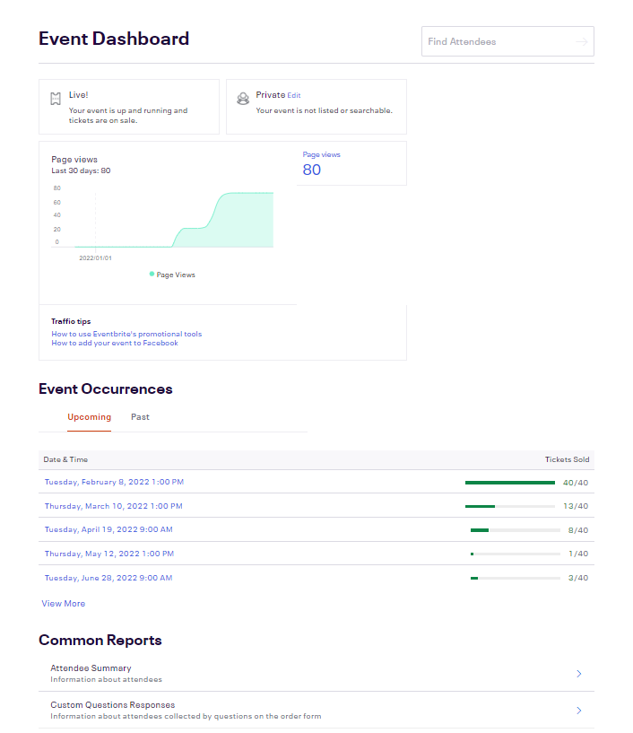

**Option 1: View Registrations**

1. On the Event Dashboard, click on the Event hyperlink (for Single) or Event Occurrence (for Recurring)
2. Scroll down to Recent Orders
3. Expand the list by clicking on View All at the bottom left of the Recent Orders area
4. Depending on your permissions, you may have the ability to view or edit the order by selecting the hyperlinked Order Number on the left most column.

**Option 2: View Roster (aka. Check-in, or Attendance List)**

1. On the Event Dashboard, click on the Event hyperlink (for Single) or Event Occurrence (for Recurring)
2. On the left side grey Event Management bar, select Manage Attendees

*TIP: If Manage Attendees is greyed out or not visible, be sure you’re on a unique Event Occurrence.*

1. Click Check-in to see the Attendee List. Note that there may be multiple pages to scroll through (bottom center)

**Duplicates and Wrong Registrations**

Both lists can be sorted by Name and Email by clicking the column header (click again to change from ascending to descending and vice versa), so that you can check for duplicates or non-City employees

Some Learning Partner permission levels allow you to Cancel or Delete Registrations. Cancel triggers an email cancellation message to the registrant. Delete just removes the record altogether, leaving no trace of its existence. Delete should ONLY be used for genuine duplicates, removing testing data, or removing “holds” or place-keeper data.

# Manage the Waitlist

[**https://www.eventbrite.com/support/articles/en_US/How_To/how-to-manually-release-tickets-to-the-waitlist?lg=en_US**](https://www.eventbrite.com/support/articles/en_US/How_To/how-to-manually-release-tickets-to-the-waitlist?lg=en_US)

**What the customer will see when they try to register:**

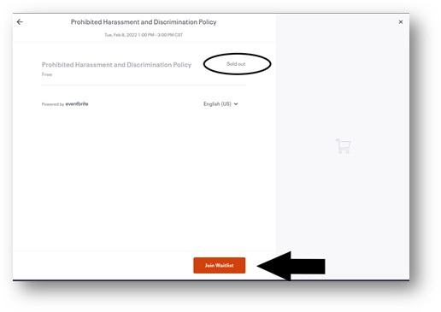

**What we’ll see in Eventbrite:**

On the Event Dashboard, you’ll see Feb 8 is at 40/40, which means all 40 seats are accounted for!

What you might want to check out . . .

* **That it’s ACTUALLY full . . .**

**Manage Attendees> Orders** > (Run Report or scroll through individual orders)

* + Look for NON-CITY EMAILS:  I saw a non-City email address and used the Employee Directory to confirm that it was a real City employee and therefore KEEP the registration.
  + Look for DUPES: When I saw Karen Miskimen was registered 2x, I double-checked to be sure that it wasn’t a registration for another employee, then I chose to DELETE the duplicate (because that doesn’t trigger an email).  Contrast that to Jay Schlimgen, who registered multiple people.  I was able to see their unique names, despite being under Jay’s email address.  Cool, right?
  + Look for DUMMY OR TEST REGISTRATIONS: Remove any moderator or facilitator registrations

*TIP: when you Cancel a ticket, a Cancellation Email is sent to the email address on file; When you Delete a registration, no email is sent – it’s as if it never happened in the first place.*

* **Check the Waitlist**

Order Options (Feb 8 Occurrence) > Manage Waitlist

* + Manually add people to the waitlist (for instance, if someone calls the office or didn’t understand that the waitlist was built in)
  + Release waitlisted people to the class as you wish (for instance, if there are only 2 people on the waitlist and you’d like to make the class capacity 42 for this session, remembering that we usually lose a person or two on the day of)
  + Export waitlisted people and send a message about future course dates (for instance, if there are too many people on the waitlist for you to allow into a session)

# Take Attendance

When: Day of/During event

* Who: Moderator or Instructor
* Where: Eventbrite > Manage My Events
* How: Manage Attendees > Check in
* Why: to ensure employees receive credit for attending events, manage future course offerings, allow you to provide follow-up communications to participants and no-shows

*Forgot to take attendance during the session? No problem! Zoom has a solution for that . . .*

**How to Pull a Zoom Usage Report**

1. Log into the Zoom account you used for the course at [www.zoom.us](http://www.zoom.us)
2. Select Reports (left side menu)
3. Select Usage Reports on the Reports page
4. Enter the date of your course in the Date fields and click Search
5. Find your course name in the list
6. Click on the Participants number (it should be hyperlinked)
7. On the Meeting Participants pop-up, select Show Unique Users
8. From here you can export the data using the Export button at the top of the pane

**How to Enter Attendance in Eventbrite**

1. Open event to take attendance

NOTE: If a recurring event, select single event occurrence from Event Occurrences section of the Event page. Remember that attendance is taken at the session/occurrence level (not the global event level)

1. Click on Manage Attendees (left menu) > Select Check-in on menu (below Manage Attendees)
2. On Attendee List, select Check in for each participant. Leave no-shows unchecked.

# Post-Course Communications

* When: Immediately following event (within 24h)
* Who: Instructor or Moderator
* Where: Eventbrite > Manage My Events > Manage Attendees > Emails to Attendees
* How: Requires completed Check-in in Eventbrite
* Why: to thank participants, provide 2nd opportunity for evaluation of course, and reinforce the value and purpose of the session OR to notify no-shows of their options for future courses

**How to Send Post-Course Communications**

1. Open event

NOTE: If a recurring event, select event from Event Occurrences section of the Event page

1. Click on Manage Attendees (left menu) > Select Emails to Attendees (below Manage Attendees)
2. On Emails to Attendees, select the Create New Attendee Email box
3. In the drop-down, To: select “Specific Attendees” and click the selection boxes to the left of each attendee in the list. (Note: you can toggle the Show field to provide a larger number of participants for ease in selection)
4. Cut and paste the text below, being sure to check the following:

* Is all required text included?
* Are font sizes and bold correct throughout? (14pt. for Thank You! And 12pt for all other)
* Is font type consistent throughout? Arial for all text
* Are links correct and tested? SurveyMonkey: <https://www.surveymonkey.com/r/LYQ39N8>

Upcoming Courses: <https://www.cityofmadison.com/human-resources/professional-development/courses>

* Did you send a test email to yourself and check how it rendered?

1. Select date/time for sending message (should be no longer than 24 hours following the event).

**Thank-You + Evaluation Email** (All Attendees)

SUBJECT LINE: Thanks for Joining Us at <<COURSE NAME>>! Tell us how we did.

TEXT: Thanks for joining <<COURSE NAME>>.  If you haven't already, we'd love it if you shared your feedback on the session - - your honest, constructive evaluation will be used to shape future versions of this and many other City of Madison courses!

[**EVALUATION**](https://www.surveymonkey.com/r/JD3RJFG)

Questions or want to get involved in this work?  Contact the instructor, <NAME>> at <<INSTRUCTOR EMAIL>>

Interested in other Learning + Development opportunities? Bookmark [Upcoming Courses](https://www.cityofmadison.com/human-resources/professional-development/courses) and check in frequently.  We're always adding new programs and sessions!

**No-Show Email** (No-Show Registrants)

TEXT: Hello! Thanks for registering for our training session titled <<BOLDED TITLE>>. We missed you at this session, but usually people tell us one of these things when they are unable to attend:

**"I was unable to attend but want to sign up for a future session"** <<FUTURE SESSIONS OF THIS COURSE>> (linked to registration address)

**“While I'm educating myself on this topic, I'm also interested in other City of Madison learning events."** Learning + Development Course Calendar

**"Where can I find more information about this topic?" or "How can I get involved in this work?"** Email the instructor, <<INSTRUCTOR NAME>> at <<CONTACT EMAIL ADDRESS>>

We hope you're well and look forward to seeing you in a future City of Madison learning event!