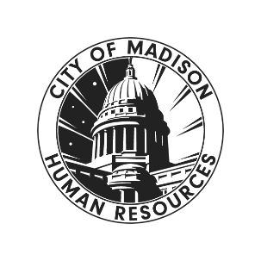
October | 2025
Issue 7
Benefits &
Human Resources

Newsletter
What’s New

Benefits
- Flex Spending Open Enrollment
- Want More Information?
- I missed the deadline!
- Vacation Carryover Requests

Organizational Development
- Project Change Triangle Sponsor Recording
- 2025 Leadership Gathering
- Human Resources Management (HRM) System

HR-Services
- Updated Course Recordings
- 2025 City/County Combined Employee Giving Campaign

HR Spotlight: Compensation Study Update

HR partnered with consultant Baker Tilly to conduct a classification and compensation study. Baker Tilly has now completed the position review as well as development of draft pay plans. Previous drafts were all reviewed for accuracy, job titles, etc.
Baker Tilly staff will be on site to host sessions on November 3rd and November 4th sharing the draft pay plans as well as the equity and benefit analyses. Once the pay plan has been communicated, Baker Tilly will finish an implementation plan and costing.
This has certainly taken somewhat longer than expected, but it is a relief to start to see the finish line. We are anticipating that we will have a final report and implementation plan ready for the beginning of deliberations of the 2027 budget.
You can register for a session by visiting our Compensation Study webpage.
Please note, registration is only required for in-person attendance, as space is limited. If you intend on joining virtually, please use the link(s) below the hybrid meeting options. Recordings will be available after the session in case you are unable to attend.



Help! I missed the deadline for Health, Dental, Vision Open Enrollment
If you or one of your coworkers/direct reports were on a Leave of Absence (LOA) or other extended, consecutive leave and missed the full Open Enrollment period for 2026 Plan Year Health, Dental, and Vision Insurance (10/6-10/31), you qualify for a special enrollment period upon your return-to-work! Please contact HR ASAP when you return, as you only have 30 calendar days from your return-to-work date to make any change(s) to benefits.
If you were not on an LOA but missed the Open Enrollment deadline, you unfortunately cannot make changes to dental or vision. However, you may still be able to make changes to health insurance via ETF’s late Open Enrollment process. For more information, please contact the Benefits Team at benefits@cityofmadison.com.

Vacation Carryover Requests
It’s that time of year again! If you have vacation in excess of 10 days (2 weeks) that you want to carry over into 2026, you need to get that request submitted to your Department Head ASAP. As outlined in APM 2-5 (the City’s Vacation Carryover Policy), Department Heads have until December 1st to submit a list to HR of all agency employees requesting vacation carryover of more than 10 days. Check with your supervisor and agency Payroll Clerk for more information!

Flex Spending Open Enrollment
The Open Enrollment period for 2026 Plan Year Flexible Spending is starting soon! This year, Open Enrollment for 2026 Plan Year Flex Spending will run from Monday, November 10th through Wednesday, November 26th. Keep an eye out for the Open Enrollment email, which will be sent on Monday the 10th and direct you to review the ESS Notification about Flex Spending Open Enrollment, and read on for some important reminders!

- Unlike with health, dental, and vision insurance, if you want to participate in Flex Spending you must make a new election each year.
- If you are planning to participate in Flex Spending for the 2026 Plan Year, be sure to read the full memo when it is published on 11/10! Besides confirmation of the 2026 maximums for both Medical FSA and DCAP, the Flex Spending memo will also include important reminders about eligibility, reimbursement process(es), qualifying events, and more.
  - Currently, IRS guidance is that the 2026 maximum for Medical FSA will be $3,400 per individual, and the 2026 maximum for DCAP will be $7,500 per household (or $3,750 for married individuals filing separately).
- Eligible expenses must be incurred during the Plan Year or its grace period.

Want more information?
We recommend you review the Flex Spending section of the Open Enrollment FAQ for answers to frequently asked questions, including:
- How does Flex Spending work?
- How do I decide whether to participate in Medical FSA and/or DCAP?
- How do I enroll for the 2026 Plan Year?
- What is the grace period for the 2025 Plan Year? What about the 2026 Plan Year?
- And more!

Employee & Labor Relations (Benefits)

Organizational Development

One City. One Team. One HR System.

#TeamCity is investing in its first-ever, city-wide Human Resources Management (HRM) System. The HRM will improve how we hire, onboard, support, and develop our staff across every department – from Fire to Finance, and Parking Utility to Public Works.
Currently, HR processes happen in too many places, on paper and in outdated processes. An HRM System will bring it all into one secure, streamlined system that supports staff, supervisors, and HR alike.

Implementing the HRM:
Together, HR and IT are planning a multi-year implementation. We are currently in the planning phase which includes the following:
- Formation of a cross-departmental project team including a steering team and implementation team.
- Project planning and contracting.
- Mapping out all current systems being used across #TeamCity, where data is being stored, and what data needs to be migrated into the new HRM system.
- Identifying what the new HRM will replace, which processes will change (and which won’t), and what all this means for each team moving forward.

NEOGOV is our current recruitment software partner. We are thrilled to grow and evolve our partnership with them beyond recruitment to support the entire employee life cycle.

NEOGOV hosted its annual User Conferences in Las Vegas in early October. The Core HRM Implementation Team participated in the 3-day event to learn about the system features, connect with other cities using the software, and meet our future support team at NEOGOV.

More information will be available as the contract is finalized, including an Employeenet site (coming soon) with regular updates.

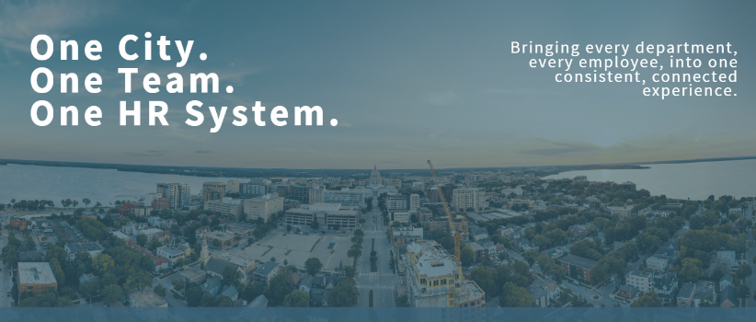

Project Change Triangle Sponsor Recording
Do you wonder about how to properly set up a project for success? Our PROSCI Change Management Certified Performance Excellence Specialist has insights for you.

In this 20-minute video on Setting up Projects for Success, we introduce a change management framework to increase the likelihood of successful project completion. This video is geared towards Project Sponsors, any individual who is responsible for final decision making, actively championing, and ensuring resources area available to support the project.

All potential Project Sponsors are encouraged to review this material. For more information, review the change management resource page. You can also request a customized change management training for a change a team is working toward through the OD consultation request process.

2025 Leadership Gathering
HR and EAP are excited to announce the Keynote Speaker for our 2025 Leadership Gathering: Leading with Humanity – Building a Culture of Care. Paul Wesselmann, MA, known to many as "The Ripples Guy," lived and worked here in Madison for two decades, and will be returning ‘home’ as this year’s Leadership Gathering Keynote.

Paul recorded this brief video greeting to help you get to know him. He also wants to hear from YOU!
He's even offered to bring a small bonus treat to leaders who share their responses by Thanksgiving, and he'll upgrade the treat if you can respond thoughtfully by November 7th. 😊

Send your responses to Madison@TheRipplesGuy.com and share the following:
- What’s meaningful for you in your current role?
- What’s not meaningful for you in your current role?
- How have you grown as a leader?
- How would you like to grow as a leader?

Register and reserve your spot today!

2025 City/County Combined Employee Giving Campaign

On October 20th the 2025 City/County Combined Employee Giving Campaign kicked off.

This annual partnership with the United Way helps fund programs which benefit members of the Madison/Dane County community and individuals throughout Wisconsin. Employees can support the campaign by visiting the “Giving Together, Growing Together” electronic pledge website at https://epledge.uwdc.org/city-county and donating to the many participating charities located there.
Employees can make one-time donations of any amount via credit card or ACH transaction, or they can sign up for weekly, bi-weekly, monthly or even quarterly donations directly from their paycheck.

You can select from hundreds of non-profit organizations - groups which assist with nutritional supplements for children, housing and transportation assistance, maintenance of parks and trails, tutoring students in need, assistance for chronically ill patients, and many other programs which benefit local and regional communities.

This year’s campaign runs until December 3. Take a moment, visit the website, and consider a contribution to the annual City-County Combined Employee Giving Campaign!

If you have questions, please contact publicsector@uwdc.org, reach out to your departmental campaign coordinator, or contact sophie.nelsonfischer@uwdc.org.

*To login to the website employees will need their 4- or 5-digit Munis Employee ID number. *

HR-Services

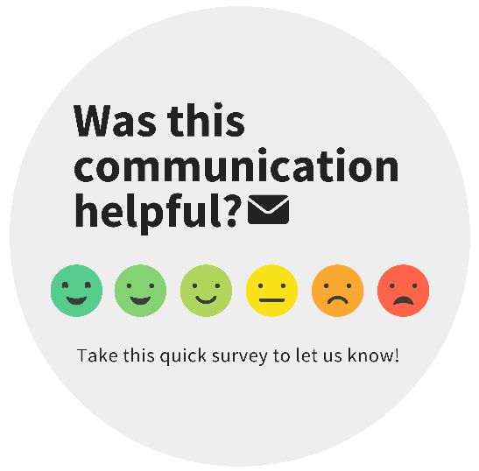
s

Common Resource Quick Links:
- Benefits Information
- City of Madison Jobs
- Human Resources Website
- Pay & Benefits

- Performance Excellence
- Organizational Development
- Supervisor Resources
- Upcoming Courses
Contact Information:
You can reach out to Human Resources mainline at (608) 266-4615 or at the email addresses listed below.
- Human Resources – HR@cityofmadison.com
- Benefits – Benefits@cityofmadison.com
- Family Medical Leave Act (FMLA) – FMLA@cityofmadison.com
- Accommodations & Access – Accommodations@cityofmadison.com
- Organizational Development – OrganizationalDevelopment@cityofmadison.com
- Inclusive Workplace – InclusiveWorkplace@cityofmadison.com

Updated Course Recordings
The HR Services team recently presented training on Hiring Foundations for Hiring Managers and Creating an Equitable Interview Process. If you could not join us or just want a refresher on those processes, please consider viewing the recordings of these sessions.

Hiring Foundations for Hiring Managers
Join our HR Business Analysts as they share best practices for talent planning, writing clear position descriptions, and moving through the hiring and recruitment process.

Creating an Equitable Interview Process
Build awareness on how bias, both explicit and implicit, can impact hiring decisions. Learn how to create an interview process by incorporating job-related behavioral questions with measurable benchmarks to effectively address bias in the interview process and for more objective candidate evaluations.

