
Next Level Leadership for Emerging & Current People Leaders Learner Workbook

Navigate this Learner Workbook:
Leadership Journey Concept 2
Horizontal Development: 2
Vertical Development: 2
Common Pitfall #1: Micromanaging 3
Common Pitfall #2: Lack of Balance 4
Common Pitfall #3: Unclear Expectations 5
Common Pitfall #3: Unclear Expectations 6
Common Pitfall #4: Lack of Feedback 7
Common Pitfall #4: Lack of Feedback 8
Common Pitfall #5: Difficult Conversations 9
Common Pitfall #6: Disconnection from Team 10
Common Pitfalls – Accountability Measures 11
Resources: 12

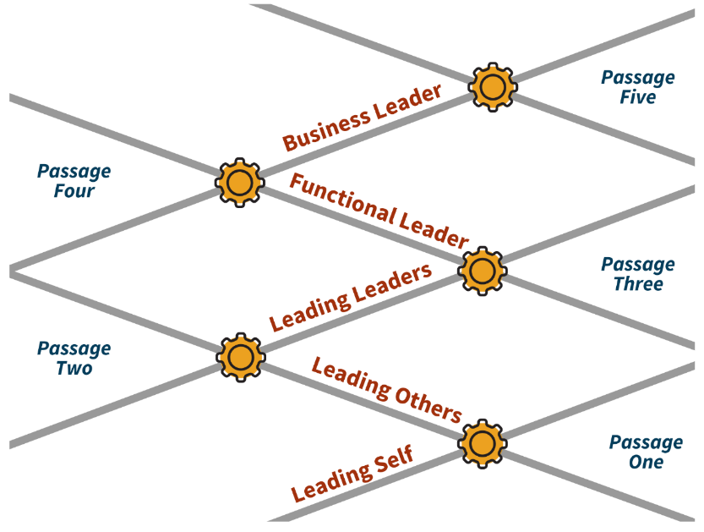
Leadership Journey Concept

Horizontal Development:

The process of adding more _______________ and _________________.
Focuses on doing ___________________________ OR filling the glass ___________________.
Example: Communication Skills.

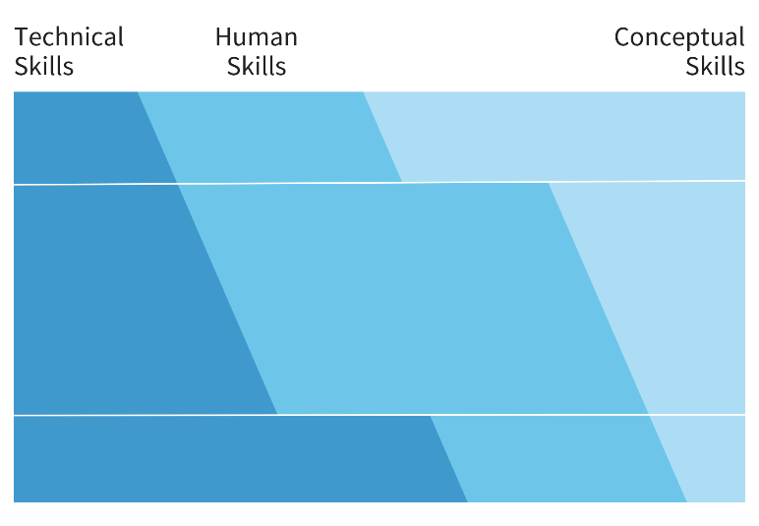

Tier 1: _______________________________________

Tier 2: _______________________________________
Tier 3: _______________________________________

Technical Skills | Human Skills | Conceptual Skills
Notes:

Vertical Development:
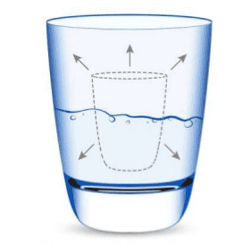
Is the process of ________________________ your ability to handle complexity by ___________________ the way you think.
Focuses on _______________________ internal capacity, being _________________, ____________________________ the glass size OR a leader’s _________________________.
Examples: Navigating Complexity, Navigating Uncertainty.
Notes:


Common Pitfall #1: Micromanaging
Diagnostic Reflection:
Reflect on a specific instance when you micromanaged, what emotions, or triggers made you feel compelled to micromanage?
Impact:
How do you believe your micromanagement affects the individuals you lead?
Horizontal Development: |  | Vertical Development:
Considering the emotions or reasons behind your micromanagement, what specific skills could you further develop to address these challenges? (e.g., delegation, trust-building, etc.). |  | What deeper beliefs or assumptions about leadership and control might be contributing to your tendency to micromanage?
What might reducing micromanagement feel like, and sound like in action? |  | In what ways can you work on developing a growth mindset, allowing for more trust in your team's capabilities? What does that feel like and sound like in action?
Feels Like: | Sounds Like: | Feels Like: | Sounds Like:
Action Plan:
What’s one specific action or behavior are you committed to consistently doing differently after reflecting on your micromanagement tendencies?


Common Pitfall #2: Lack of Balance
Diagnostic Reflection:
Reflect on an instance or context where you find it challenging to say no or set boundaries.

Impact:
How do you find the challenge of saying no or setting boundaries impacts your own well-being and your leadership effectiveness?

Horizontal Development: |  | Vertical Development:
What specific skills could you further develop to address these challenges associated with your lack of balance? (e.g., time management, priority setting, delegation, etc.). |  | How can you cultivate self-awareness to recognize the early signs of imbalance and address them proactively?
What might this development feel like, and sound like in action? |  | In what ways can you develop resilience and cope with the discomfort of saying no when necessary?  What does this look like and sound like?
Feels Like: | Sounds Like: | Feels Like: | Sounds Like:
Action Plan:
What’s one specific action or habit you’re committed to consistently doing differently to establish and maintain balance in your professional life?


Common Pitfall #3: Unclear Expectations
Diagnostic Reflection:
Can you recall specific instances where unclear or assumed expectations led to misunderstandings or challenges within your team?
Impact:
How do you believe unclear expectations impact team morale, productivity, and the overall work environment?
Horizontal Development: |  | Vertical Development:
What specific communication skills could you develop horizontally to mitigate unclear or assumed expectations? ((e.g., active listening, asking clarifying questions, feedback mechanisms). |  | Reflect on your beliefs about authority, “professionalism” and communication. Are there any deep-seated assumptions and/or biases that contribute to unclear expectations?
What might this development feel like, and sound like in action? |  | In what ways can you develop patience, open mindedness and empathy to navigate communication challenges with a clearer mindset?
Feels Like: | Sounds Like: | Feels Like: | Sounds Like:
Action Plan:
What specific actions or habits are you committed to consistently doing to improve the clarity of expectations within your team?

Common Pitfall #3: Unclear Expectations
Remember the Three C’s:
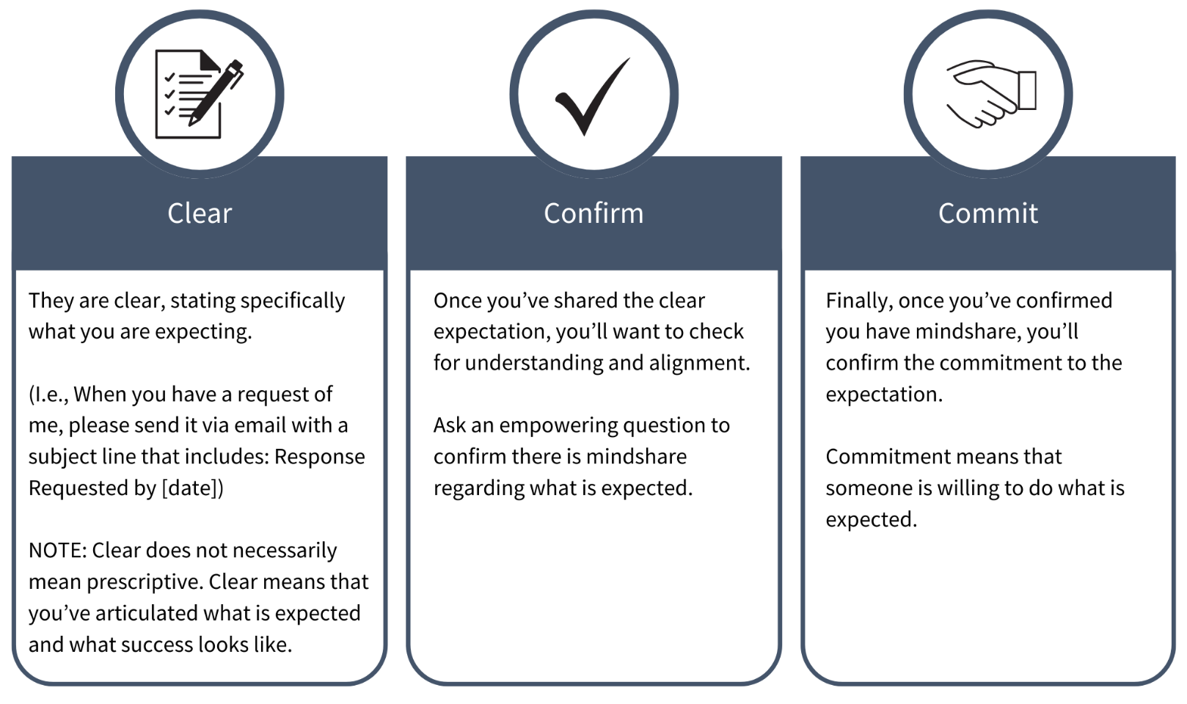
Notes:


Common Pitfall #4: Lack of Feedback
Diagnostic Reflection:
Reflect on your beliefs about feedback. Are there any deep-seated assumptions, biases, reasons or fears that contribute to your current beliefs?

Impact:
How do you think a lack of feedback impacts team dynamics and individual growth within your team? OR How do you think feedback improves team dynamics, performance and individual growth within your team?

Horizontal Development: | Vertical Development:
How can you improve your ability to give clear and trauma informed feedback in a way that is actionable and fosters a positive working relationship? | How can further developing your emotional intelligence help you to better understand the impact of feedback on individuals and tailor your approach accordingly?
Action Plan:
What specific actions or habits are you committed to consistently doing to foster a culture of feedback within your team? (e.g.: implement regular feedback sessions with your team to ensure that both positive and constructive feedback are consistently provided).

How will you involve your team in the feedback process and seek their input on improvements?

Common Pitfall #4: Lack of Feedback
Remember SBI + I^2
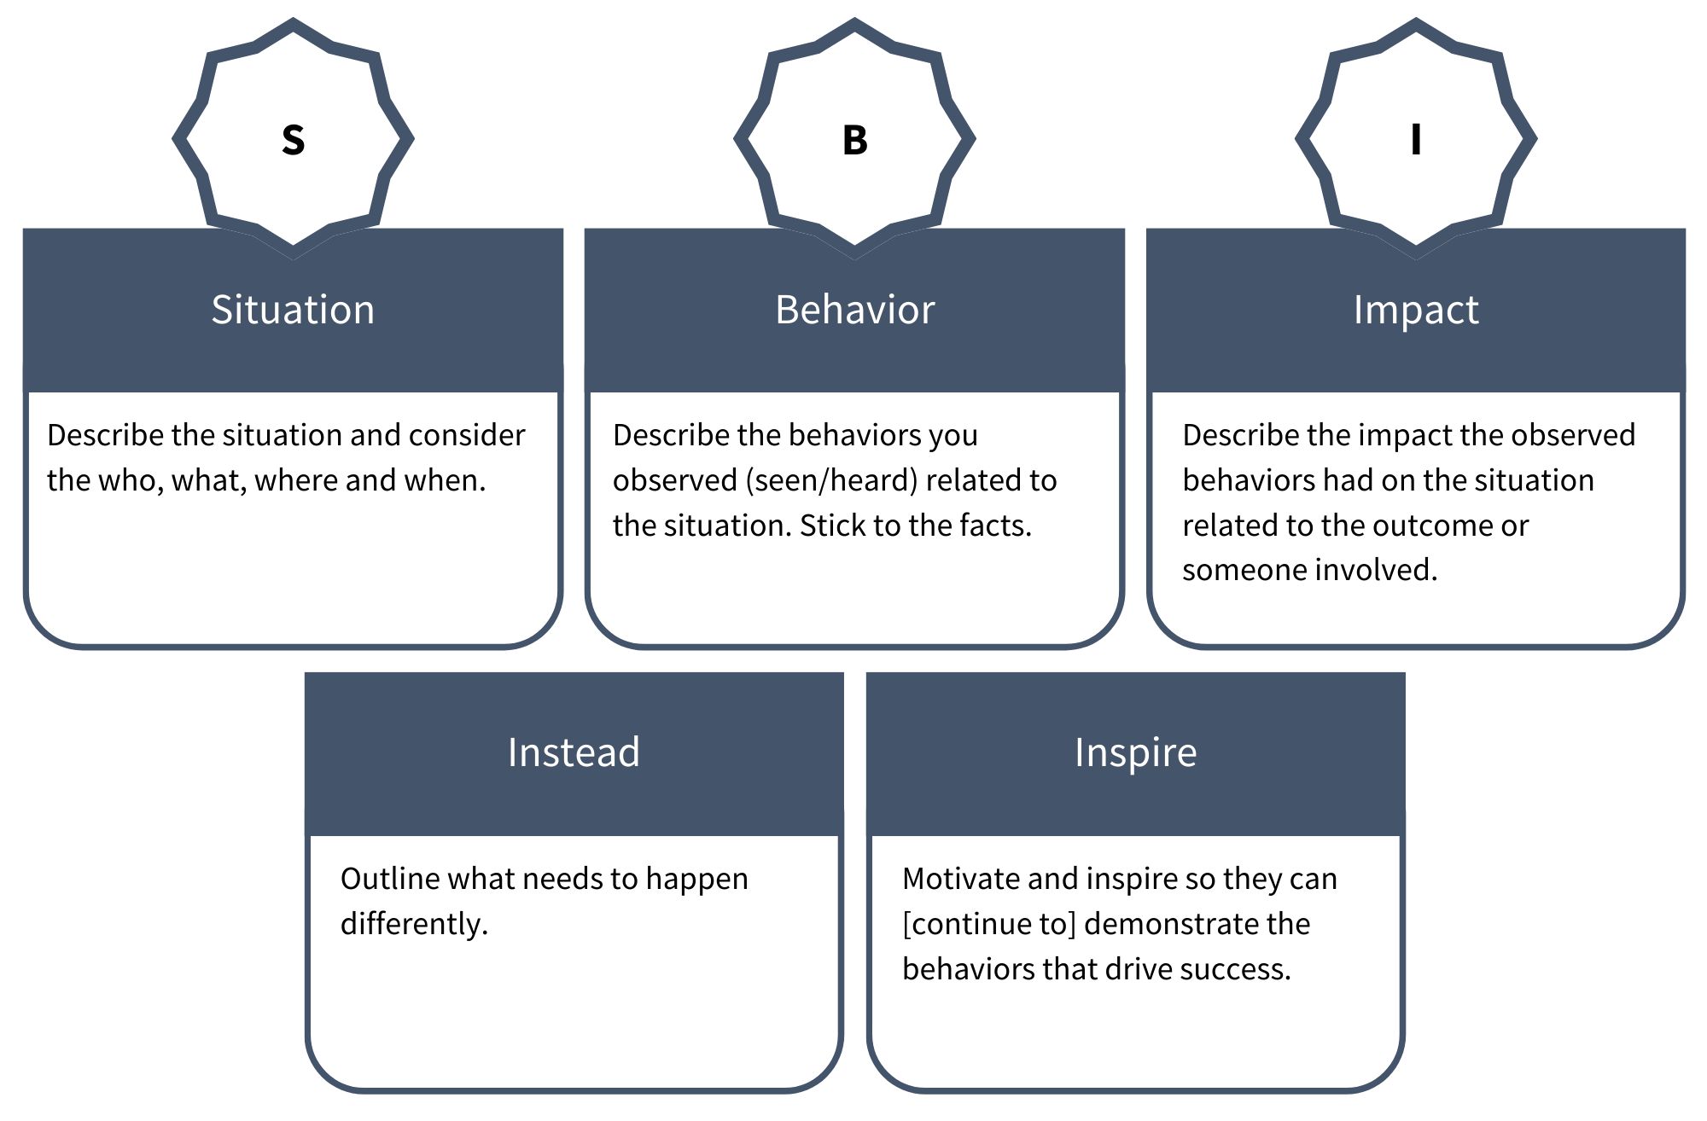
Notes:


Common Pitfall #5: Difficult Conversations
Diagnostic Reflection:
Reflect on a specific instance where you found it challenging to have difficult conversations? What emotions, assumptions, or biases were present during those situations?
Impact:
How do you believe avoidance of difficult conversations impacts team dynamics and overall performance?
Horizontal Development: | Vertical Development:
How can you improve your ability to frame and structure difficult conversations to ensure they are constructive , trauma informed and solutions-oriented? | How can you cultivate emotional intelligence to better understand your own reactions and those of others during challenging discussions?  In what ways can you develop resilience and courage to navigate difficult conversations with a clearer and more composed mindset?
Action Plan:
What one specific action or habit you’re committed to consistently doing to improve your ability to have difficult conversations?

Are there mentors or colleagues who excel in handling difficult conversations that you can seek guidance from?


Common Pitfall #6: Disconnection from Team
Diagnostic Reflection:
What beliefs or concerns about vulnerability, trust, “professionalism” or team dynamics do you currently hold that could contribute to a sense of disconnection?

Impact:
How do you think this disconnection impacts team morale, collaboration, and overall productivity?

Horizontal Development: |  | Vertical Development:
What specific communication and relationship-building skills could you further develop horizontally to mitigate the challenges associated with feeling disconnected? (e.g., active listening, team building activities, fostering a collaborative environment). |  | Reflect on your mindset towards leadership. Are there fixed beliefs about maintaining distance or authority that contribute to a sense of disconnection?
What might this development feel like, and sound like in action?
Feels Like: | Sounds Like:
Action Plan:
What specific actions can you take to create a team culture that values open communication, collaboration, and a sense of belonging? (e.g.: team-building activities, both formal and informal, open communication, collaboration, and a sense of belonging).

Common Pitfalls – Accountability Measures
 | - Micromanaging
 | - Lack of Balance
 | - Unclear Expectations
 | - Lack of Feedback
 | - Difficult Conversations
 | - Disconnection from Team

Resources:

Articles:
- New Trends in Leadership Development – Worldsview Academy
- Rising to the Top: How Vertical Leadership Can Transform Your Organization – Pedro Pinto
- What is Vertical Leadership? – Indeed Editorial Team
- Vertical Development Can Make You a Better Leader – Dede Henley

Book:
- Vertical Growth: How Self-Awareness Transforms Leaders and Organizations – Michael Bunting, Carl Lemieux

