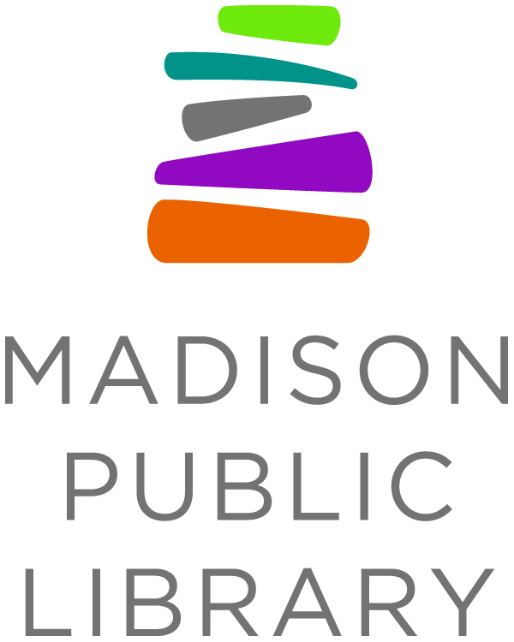
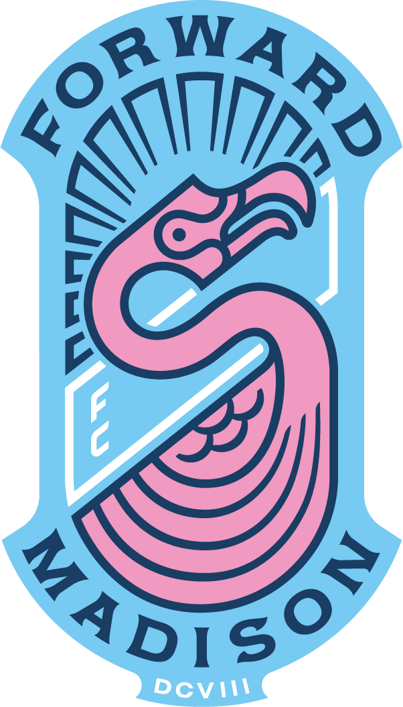
For Immediate Release: May 10, 2021
Library Contact: Tana Elias, Digital Services & Marketing Manager, Madison Public Library, 608-225-0619, telias@madisonpubliclibrary.org
Forward Madison Contact: Jason Klein, Forward Madison FC, jason@forwardmadisonfc.com

Forward Madison FC and Madison Public Library Team Up to Promote Reading

MADISON, WI--Forward Madison FC and Madison Public Library are announcing an ongoing strategic partnership to promote literacy and support young writers in Madison. This summer, the two organizations are teaming up to provide opportunities for nontraditional library users to get introduced to the joy and excitement reading and other media can bring!

“We appreciate the opportunity to kick off this program with the Madison Public Library,” Forward Madison FC Chief Operating Officer/Owner Conor Caloia said. “There is no better off the field summer activity than picking up a good book. We look forward to joining the Library to promote reading and literacy this summer and beyond.”

On select dates throughout the soccer season, Madison Public Library’s mobile library, the Dream Bus, will be stationed outside Breese Stevens Field to help get fans signed up for library cards, offer outdoor browsing of materials and hand out swag for the We Read program. In fact, there will be a special, limited edition We Read in a Flock sticker for kids and families to enjoy.

“The Flock was born from tenets such as community, inclusivity, and accepting individuals from all walks of life,” said At-Large Director Grant Pieters. “Paramount to achieving these ideals is The Flock’s steadfast commitment to championing a vast array of perspectives from artists and authors, both inside and outside of the soccer landscape. Just as a soccer supporter does not have to look or think a certain way, a reader doesn’t, either."

We Read is a year-round, all-ages, community wide celebration of all kinds of reading. To participate, Madisonians can simply find something to read that they love, share it with a friend or on social media and join in the conversation about reading using the hashtag #WeReadMadison. There will be a variety of ways for Madisonians to engage with We Read this summer through their neighborhood library and out in the community. http://www.madpl.org/weread

Forward Madison FC, The Flock and Madison Public Library have worked together in the past to encourage young local writer Tikeh Tazeh who penned and self-published the book Hat Trick, a story about a young man who loves soccer.

Tikeh and his whole family got to meet player Connor Tobin and Head Coach Carl Craig from Forward Madison FC, as well as Grant Pieters of The Flock. Tikeh received a big surprise when Forward Madison gifted him some team swag and purchased copies of his book to sell at the team gift shop. As Forward Madison FC, The Flock and Madison Public Library formalize their partnership, they are working to support and encourage other young writers in the community by introducing a young writers’ competition.

The “We Read: Youth Voices” Young Writers’ Contest is focused on writers aged 18 and under who have a story to share. Inspired by this collaboration, the theme of the contest will be Teamwork, but entries should not limit the definition to sports. Any short story, poem, song, rap, or creative written expression of people working collaboratively for a common goal is encouraged. The contest will begin June 12th and the deadline for submission is September 17. Tikeh Tazeh will serve as a youth ambassador for the contest and winners will be announced in October, featured as a part of the Wisconsin Book Festival, and honored at one of the final games of the season in October. Visit madpl.org/youthvoices for submission details beginning in early June.

"As a passionate soccer fan, an avid reader and a writer, it is an incredible honor to be the youth ambassador for this inaugural writers’ competition,” said Tazeh. “I think this event will provide a great platform for fellow young writers to showcase their talents and I am very excited to be a part of it."

While the story contest is just for youth, We Read is for everyone, anytime. Madison Public Library went Fine Free in August 2020 and will begin welcoming people back to their library locations in-person starting on Monday, May 24.

“Madison Public Library is excited to be in partnership with Forward Madison and their supporters,” said Mickells. “It comes at an important time as we begin to reopen our libraries, and as we continue to reach out to young people in many ways with our community partners to promote the importance of reading. Go We Read. Adelante, Leemos! and Go ‘Mingos!”

The Forward Madison FC season began on May 8 and will continue through October. Additional events will be announced as part of the partnership with Madison Public Library throughout the year and into the future.

Fans will be able to visit the Dream Bus at Breese Stevens Field during the following Forward Madison FC games:
- Saturday, May 15 (first home game of the season)
- Saturday, June 12
- Saturday, July 24
- Saturday, September 11
- Saturday, October 30 (final home game of the season)
Learn more about this partnership at madpl.org/forward

About Madison Public Library
Madison Public Library’s tradition of promoting education, literacy and community involvement has enriched the City of Madison for more than 140 years. Visit the library online at www.madisonpubliclibrary.org, madisonpubliclibrary on Facebook, @madisonlibrary on Twitter, or @madisonpubliclibrary on Instagram.
About Forward Madison
Forward Madison FC is an extension of the shared belief of Madisonians that community is built brick by brick and day by day with inclusion, transparency, and a communal desire to provide the best quality of life for all. We believe that sport, especially soccer, can be a vehicle for this. Visit Forward Madison online at forwardmadisonfc.com, Forward Madison FC on Facebook, @forwardmsnfc on Twitter and @forwardmadisonfc on Instagram.

About the Dream Bus
The Dream Bus began delivering service in April of 2019. Madison Public Library, in partnership with Dane County Library Service and Madison Public Library Foundation, recognized that many Madison-area communities experienced barriers to accessing library services. The Dream Bus is a joint effort by all three organizations to alleviate those barriers. Learn more at dreambus.org

