 |  |  | CITY OF MADISON PARKS DIVISION  Group Volunteer Registration and Release Form |  |  |  |  |  |  |  | 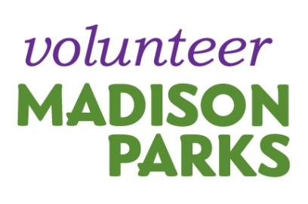
INFORMATION
DATE: |  | START TIME OF PROJECT: |  |  |  |  | END TIME OF PROJECT: |  |  | TOTAL HOURS:
PROJECT DESCRIPTION: |  |  |  |  |  |  |  |  | PARK LOCATION:
MAIN CONTACT: |  |  |  |  | EMAIL: |  |  |  | PHONE NUMBER:

RELEASE STATEMENT
I understand that my services are being offered on a voluntary basis without anticipation of financial remuneration. I grant permission for my photo to be used in any promotional materials produced by the City of Madison Parks Division. I shall indemnify and hold harmless the City of Madison, its Board and Commissions and their officers, agents and employees from and against all claims, demands, loss of liability of any kind or nature for any possible injury incurred during volunteer service. If you are 18 and under, you need a parent or guardian signature to participate.

By signing this form, I agree to the terms of the release statement.

PRINT NAME/SIGN | BEST CONTACT EMAIL/PHONE | TOTAL HOURS

