Hello Midtown Community!
Although it doesn’t quite yet feel like it, fall is here. I wanted to take a moment and talk about property crime prevention, because the still-warm weather means windows and garage doors may be open, and the coming colder weather means warming up unattended cars, all of which increases vulnerability to opportunistic (and sometimes organized) thieves.
I am reaching out to you because MPD needs your assistance in order to prevent and reduce property crime. Policing in partnership with the community is not only a core value of ours, but it is also a requirement to effectively combat crime, especially property crimes which can literally happen anywhere at any time. The fact is we can’t always be where you live, work, and play—and it is with that truth in mind that I am asking for your help.
What can you do? Below is a card with some very useful information that helps to harden your home, car, or business. The harder you make it for thieves, the less likely you will be a victim!

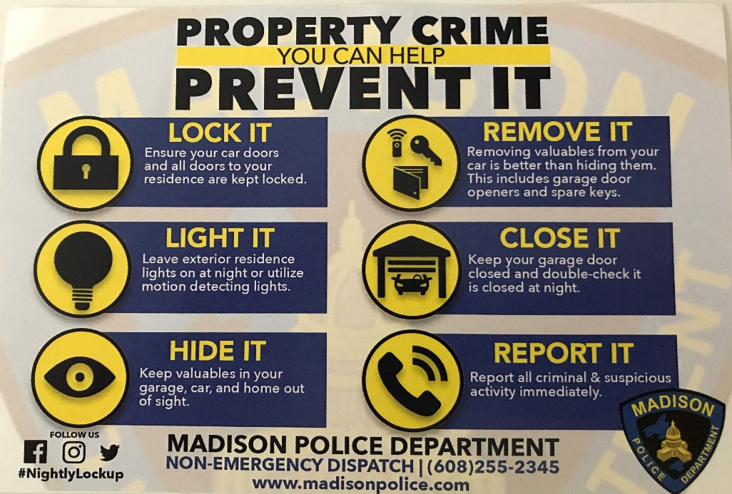

Finally, we rely on information in order to allocate resources and investigate crimes. Please let us know if you are seeing suspicious activity or behavior, have a concern, or have been a victim of a crime!
Emergencies and in-progress crimes 911
Non-emergency 608-255-2345
Crime-stoppers 608-266-6014

We cannot eliminate property crime, but I know that by working together we can reduce it and its impact on our community!

Captain Jason Freedman
jfreedman@cityofmadison.com
Midtown Police District

