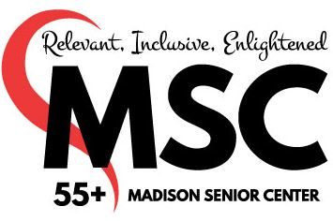
Artist # ________
Artful Affair
2026 Registration Form

First & Last Name _______________________________________________ Birthdate _____________
Email Address __________________________________________________ Phone ________________
Address _______________________________________ City __________________ Zip _____________

The Madison Senior Center (MSC) respects and values each art object and takes special precautions in handling and displaying the art. All artists display their work at their own risk with no responsibility for damages assumed by the MSC. I read the guidelines and understand that the exhibit will be open May 8 – July 6, 2026. Artwork will be available to be picked up on Tuesday, July 7, 2026. I agree to donate 10% of any artwork sold during Artful Affair to the Madison Senior Center Foundation.

Signature _____________________________________________ Date ________________

Tape the labels below to the back of the corresponding piece of art.


Entry 1 Artist # ________
Title _____________________________________________
Medium __________________________________________
Price __________________ Not For Sale

Entry 2 Artist # ________
Title ____________________________________________
Medium _________________________________________
Price _________________ Not For Sale

Entry 3 Artist # ________
Title ___________________________________________
Medium ________________________________________
Price __________________ Nor For Sale

