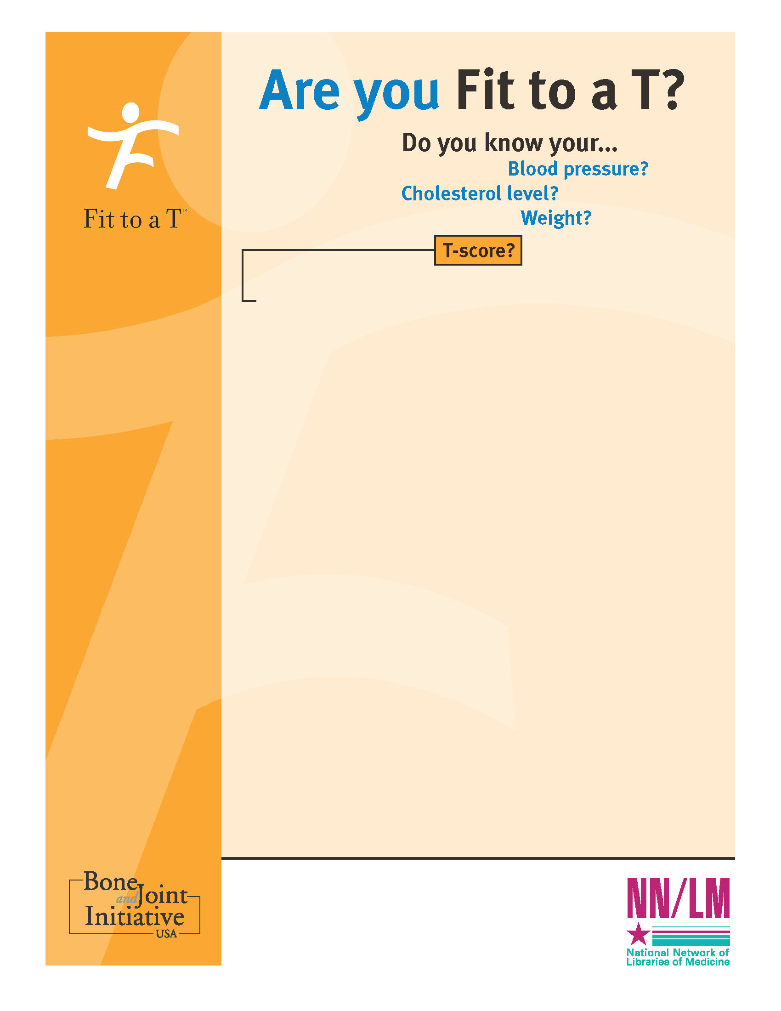

That’s right, T-score. If you had to think twice about what a T-score is, and no, it’s not a golf term; chances are you’re not alone.

It’s all about your bones. If you want to shop ‘til you drop, golf ‘til your legs ache and line dance ‘til you’re 84 – knowing that your bones won’t let you down – here’s what you need to know.

**FREE – OPEN TO THE PUBLIC**

**WHAT: *Fit to a T*** bone health and osteoporosis education  
program, for men and women of all ages

**SPEAKERS: Jamie McKeon, PT**

**WHEN: Tuesday, March 24, 2015**

**at 10:00 AM**

**WHERE: Madison Senior Center**

**330 W.** Mifflin St

**Madison, WI**