
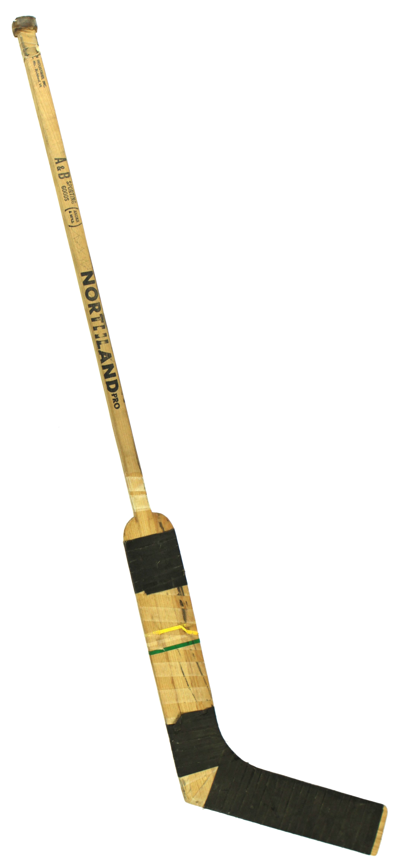
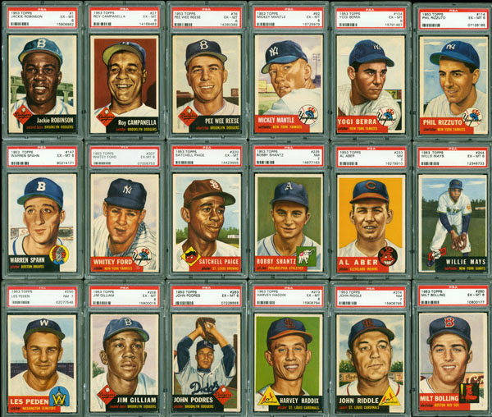
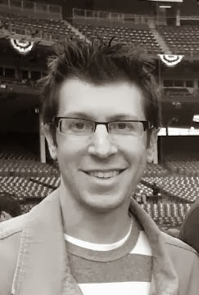

Learn about the history of vintage card collecting and then have your vintage collectibles appraised (for free) by expert appraiser Michael Osacky of www.baseballintheattic.com.

Monday, September 8 at 1 pm
Call 266 6581 to register

Michael is a regular contributor
to Parade Magazine &
has written articles for
The New York Times,
Huffington Post, &
Kiplinger's Magazine.

