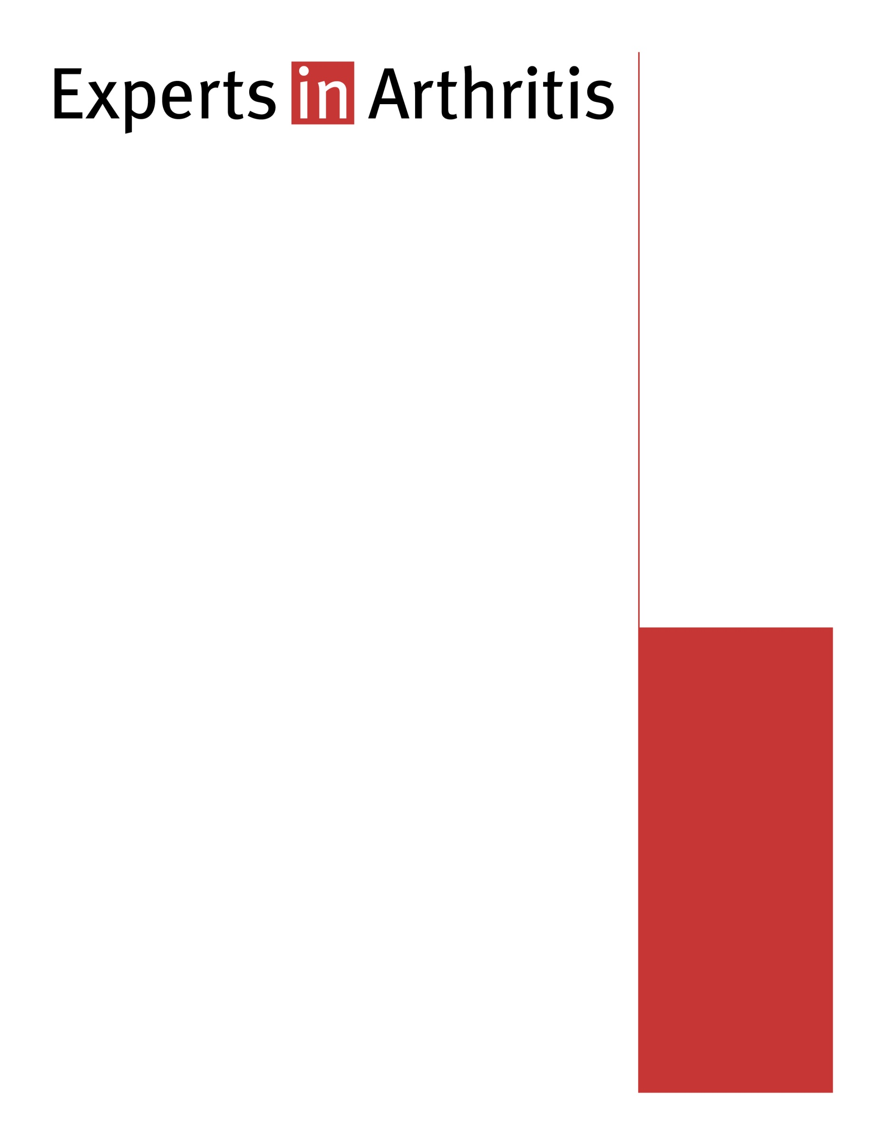

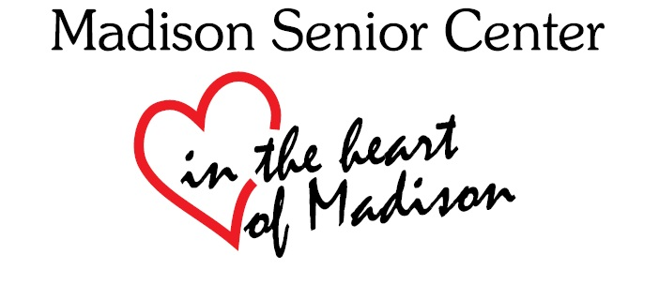

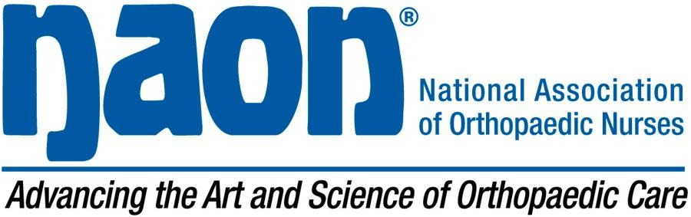

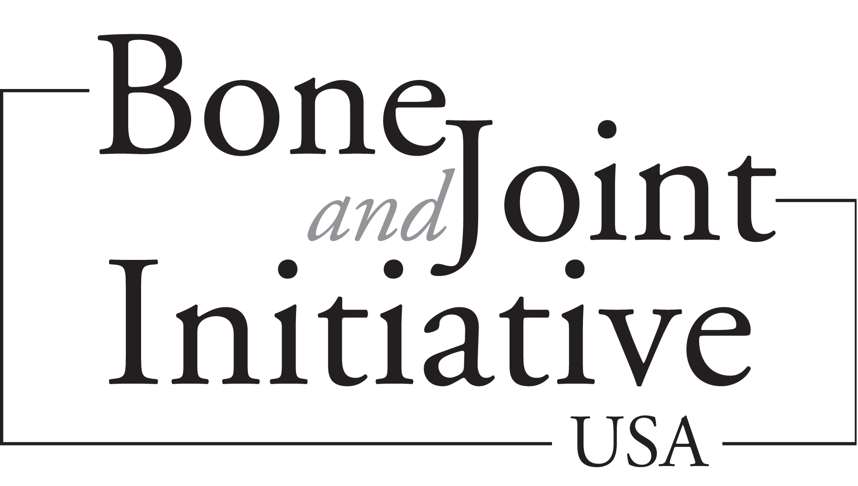

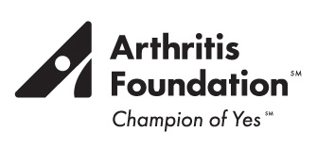

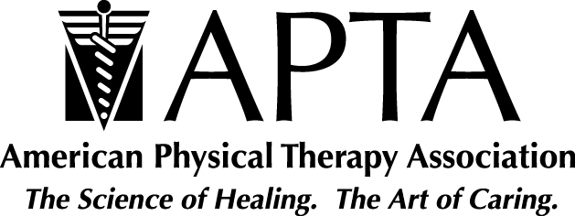



**In collaboration with:**

American Academy of

Pediatrics

American Legion Auxiliary

The Arthritis Program, Centers for Disease Control and Prevention

Natl. Association of Colored Women’s Clubs

Natl. Black Nurses Association

Natl. Hispanic Council on Aging

Natl. Institute for Arthritis and Musculoskeletal and Skin Diseases

Natl. Institute of Senior Centers

Operation Change- Chicago

Public Library Association

The YMCA

Free resources will be provided

Please register by June 9th, Call 267-8650

***A FREE public seminar for people with arthritis and people who care about them***

Meet experts in arthritis care who will inform you about current scientific evidence and management strategies in the treatment and care of **osteoarthritis, rheumatoid arthritis, and juvenile arthritis.**

**When:** Monday, June 13, 2016

10:00 AM – 11:00 AM

**Where:** Madison Senior Center

330 W. Mifflin St.

Madison, WI

**Program Overview**

* What YOU Can Do to Manage Your Arthritis: Practical Strategies to Take Control of Arthritis with Updates on:
  + The Role of the Patient in Disease Management
  + The Role of Nutrition and Exercise in Disease Management
* Question and Answer breakout session with clinical and research answers on:
  + Rheumatoid Arthritis
  + Osteoarthritis
  + Juvenile Arthritis

**Speaker Names: Ryan DeRose, PT**