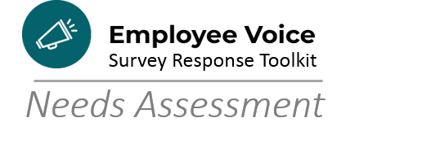

Creating Employee Voice Survey Action Plans
Instructions: Read the statement and mark the box that best corresponds to your level of knowledge/expertise in that topic.

Action Plan Column |  | Novice  1 | Advanced Beginner  2 | Competent  3 | Proficient  4 | Expert  5
 | Synthesizing various departmental work plans
A | Breaking projects into smaller tasks
B | Connecting goals and tasks to organizational priorities (in this case, the EVS Goals: Employee Engagement, Employee Development,  Communications)
C | Setting S.M.A.R.T.E. goals
D | Measuring goals and revisiting progress
D | Setting performance measures
E | Reviewing team workload and capacity
E | Identifying over- or under-allocated staff
E | Identifying who is responsible, accountable, informed, and consulted in decision-making and work planning
E | Distributing work in line with the skills, passions, and development needs of my team members
F | Prioritizing work that needs to be completed
F | Motivating the team when activities on the work/action plan feel “stuck”
G | Kicking off new action plan steps
G | Closing items once the work is complete
G | Creating a central location where the team can see how they are performing
H | Setting Timelines
I | Defining resources needed to complete tasks
 | Rewarding my team when we meet a goal
 | Recognizing outstanding achievements on our team

Tally your results:

1s and 2s: _______ 3s: ______ 4s and 5s: ________

Mostly 1s and 2s: The Action Plan Getting Started Guide was made for you! Walk through the entire workbook in order. Activities build upon one another to help teams move from the general to the concrete, in a step-by-step process.

Mostly 4s and 5s: The Getting Started Guide is also useful for discreet activities that can help teams dig deeper into analysis. Pick and choose the sections that will help you get the most out of your planning.

The Getting Started Guide is available in PDF and Word so that you and your staff can work electronically or with paper versions to bring the Employee Voice Survey data from analysis stage to action item stage.

Looking for more resources on . . .

- Goal Setting

Psychology Today Goal setting assessment: https://www.psychologytoday.com/us/tests/career/goal-setting-skills-test

Mind tools Goal setting assessment: https://www.mindtools.com/pages/article/goal-setting-quiz.htm

S.M.A.R.T. Goals Learning module Mind tools https://www.mindtools.com/pages/article/smart-goals.htm

