Basics of Learning Experience Design (LXD)
Learning Objectives Builder

Instructions: Move left to right, strengthening your initial Draft Learning Objectives to arrive at a finalized Learning Objective/s in the right column. Remember, this is a sequential, but not always linear process. You may arrive at a learning objective and realize that you could “up the ante” and make that learning objective more practical, meaningful, or measurable at a higher or lower level of Bloom’s taxonomy.
Enter the Session Title | Develop the Learning Outcome  Following completion of this module, what should the learner be able to do or demonstrate related to that skillset? | 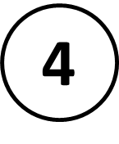  Make it more actionable using Bloom’s Taxonomy Bloom’s Word Wheel  What action must the learner take to get to the Learning Outcome? | 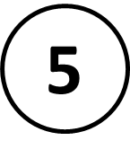  Strengthen the Learning Objective using CABD Builder  What are the condition, actor, behavior, and degree? | Write and Evaluate your finalized Learning Objectives  What grade would you give your Learning Objective relative to the criteria?  - Outcome-oriented  - Meaningful to the learner  - Achievable
Enter session title here

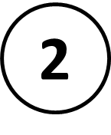
Enter 1st learning outcome
topic here
Enter 2nd learning outcome
topic here
Enter 3rd learning outcome
topic here
