Basics of LXD Week 1: Foundations of Adult Learning
60-90 min elapsed

Now that we have explored what Learning Experience Design is and its learner focus, it’s time to dig deeper and work with our learning squad to strengthen the learning objectives for our courses.
Learning Objectives
After this assignment, you’ll be able to:
- Evaluate previous material and identify opportunities to improve focus on learner experience in your learning objectives
- Given Bloom’s Taxonomy, the Bloom’s Taxonomy Wheel, CABD, build learning objectives that meet the criteria for each module
- Brainstorm activities that can help you ensure that the learning objectives are met in ways that involve learners, encourage sharing of experience, make content relevant to learners, and stay problem-centered
Assignment Outline
Learn/Reflect (30 min): Foundations of Adult Learning Theory
- Review Week 1 Material – LXD: The Why, The How, The What
- Great LXD is Learner-Centered

Learn & Reflect
Review of LXD: The Why, The How, The What
Reflect (Optional, 3 min)
Why: Learners at the Center
Reviewing the group-generated “Learner Centered looks like, sounds like, feels like . . .” ideas, which are the statements that really resonated with you?

Watch (Optional, Video: What is ADDIE? Ray Pastore, 4 min)
How: Learning Experience Design (The “Design” part of A.D.D.I.E.)
What is ADDIE? In this video Pastore describes the basic instructional design model ADDIE. This video is designed for those brand new to the field.

Read (NovoEd Shortsheet, 3 min)
What: LXD Module Design Rubric
The purpose of a rubric is to provide criteria and qualities that indicate what the intended outcome of that design element achieves. There are 5 criteria in the LXD Module Design Rubric that we’ll cover over the course of 3 weeks

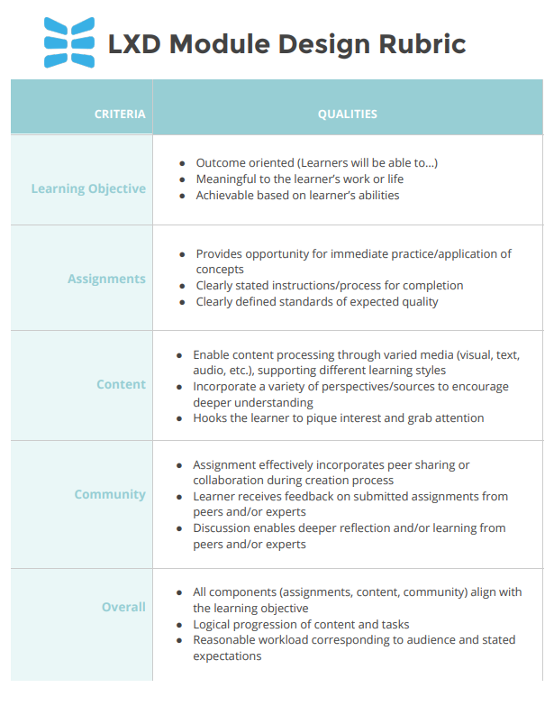
NOTES:

Week 1 Assignment

Take Action: Map Your Course
Instructions: Click on the “SmartArt” below and notice that you can replace the placeholder names with your own information to help draw a better picture of how your course (may) fit into the larger scheme of learning and development in your agency or in the City of Madison. Note: If your session is more of a “stand alone” session, then you can ignore the Series Name. And remember that you might be building a COURSE, if you are able to deliver all the content in one module. But also remember that you have the ability to string together multiple modules to fulfill the learning objectives of a course. For the sake of this Basics of LXD course, just choose one module to focus on.
Definitions

Series = Broad Topic
Ex. Learning Curve Series

Course = Narrow Topic
Ex. Basics of Learning Experience Design (LXD)

Module = Specific Skill Sets
Ex. Session 1: Fundamentals of Adult Learning

Learn & Reflect: Building Learning Objectives

Building Learning Objectives
To set the foundation for the following assignment, it may be helpful for you to dig a bit deeper on how learning objectives are created, the history of key learning models, and deepen your understanding of how learning experience designers move from an abstract concept or topic to learning objectives that meet core criteria of being outcomes-oriented, meaningful to the learner, and achievable given the time allotted for learning.

Bookmark (Website, 10 min)
Bloom’s Taxonomy
In 1956, Benjamin Bloom with collaborators Max Englehart, Edward Furst, Walter Hill, and David Krathwohl published a framework for categorizing educational goals: Taxonomy of Educational Objectives. Familiarly known as Bloom’s Taxonomy, this framework has been applied by generations of K-12 teachers and college instructors in their teaching.
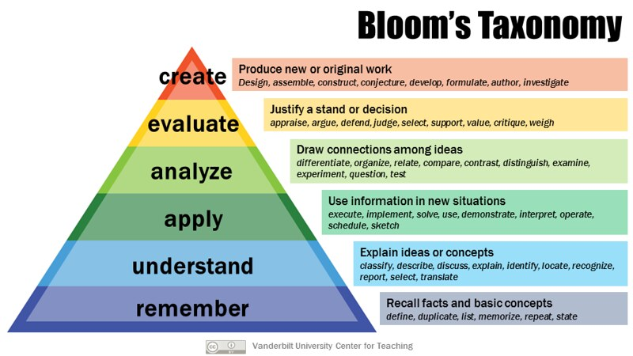
Watch (Video, 5 min)
Going Beyond Blooms to Actions
An excellent explainer video that focus on creating great learning objectives that go beyond Bloom's, by being specific, measurable, and target-audience focused.

Read (Blog, 5 min)
Why You Want to Focus on Actions, Not Learning Objectives
This article by Cathy Moore reinforces the notion that learning objectives should focus on the action and outcome, not the theory.

Reflect (7 min)
Some questions to consider as you’re reading, watching, learning . . .
Why should we be explicit with our learning objectives for adult learners?
What happens if we skip over or keep learning objectives too general?
What does an organized set of objectives do for the instructor with regard to . . .
- Planning?
- Delivery?
- Assignment Tasks?
- Evaluation?

Take Action: Use the Learning Objectives Builder (20 - 30 min)
3Instructions: Move left to right, strengthening your initial Draft Learning Objectives to arrive at a finalized Learning Objective/s in the right column. Remember, this is a sequential, but not always linear process. You may arrive at a learning objective and realize that you could “up the ante” and make that learning objective more practical, meaningful, or measurable at a higher or lower level of Bloom’s taxonomy.
3
Enter the Session Title | Develop the Learning Outcome  Following completion of this module, what should the learner be able to do or demonstrate related to that skillset? | Make it more actionable using Bloom’s Taxonomy Bloom’s Word Wheel  What action must the learner take to get to the Learning Outcome? | Strengthen the Learning Objective using the CABD Builder  What are the condition, actor, behavior, and degree? | Write and Evaluate your finalized Learning Objectives  What grade would you give your Learning Objective relative to the criteria?  - Outcome-oriented  - Meaningful to the learner  - Achievable
Enter session title here

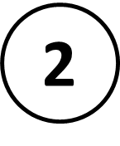
Enter 1st learning outcome
topic here
Enter 2nd learning outcome
topic here
Enter 3rd learning outcome
topic here
(repeat as needed)
Deeper Dives (Optional)
- What are some problems with Bloom's Taxonomy? Learn more about What's Wrong with Bloom's Taxonomy
- Can online learning be the magic bullet? Learn the ways in which online learning can be better than in-person learning.
Learn & Reflect: Embedding Equity in Adult Learning
Bookmark (Blog, 5 min)
The Adult Learning Theory – Androgogy – of Malcolm Knowles

- Keep Adult Learners Involved: You should try to give learners discretion to choose options, paths, topic of their assignments.
- Encourage Sharing of Experience: You should assume that learners may have relevant experience, and you can invite them to share their experiences; assignments should be broad enough for learners to apply their own experience to it.
- Make it Relevant and Impactful to Learners' Lives: You can ask learners to observe, reflect, try out, and apply concepts to a current challenge that they are facing.
- Keep it Problem-Centered: Keep the assignment focused on an authentic problem of reasonable scope (but allowing for nuance), and be more open-ended on the potential solutions.

Read (Excerpt from Dismantling Racism: A Workbook for Social Change Groups, 15 min)
The Characteristics of White Supremacy Culture
A list of characteristics of white supremacy culture which show up in our organizations. Culture is powerful precisely because it is so present and at the same time so very difficult to name or identify. The characteristics listed below are damaging because they are used as norms and standards without being pro-actively named or chosen by the group. They are damaging because they promote white supremacy thinking. They are damaging to both people of color and to white people. Organizations that are people of color-led or a majority people of color can also demonstrate many damaging characteristics of white supremacy culture.
Reflect (5 min)
How does White Supremacy Culture sideline learning experiences?

