Week 2 Assignment: Basics of Learning Experience Design (LXD)

Designing for Learner

Lesson Objectives
- Given a lesson plan template and guidance document, the participant will organize a Lesson Plan for their course that meets the LXD criteria.
- Given the anatomy and function of a course module, the participant will design a course module that extends the learning experience beyond the classroom session.
Assignment Outline
Learn/Reflect: Designing for Learner & Facilitator
- Review Week 2 Material
- Designing for Learner: Helping learners chunk content into modules, using 3 parts (Content, Assignments, Community/Collaboration)
- Designing for Facilitator: Using Lesson Plans to help organize yourself and your stuff

Learn & Reflect
Reflect (7 min)
How did the quality and quantity of your learning objectives change when you applied the resources in the Learning Objective Builder?

What are the verbs used in each of your learning objectives? Will that level of learning get learners where they need to be? Is there a way to move learning objectives to higher-order thinking skills?

Designing for Learner: Modular Learning

Why Modules?
Organizing content by modules can ease the cognitive load of the learner, by helping the chunk like information together to build knowledge and skill, then reinforce it through collaborative learning activities. While there is no perfect formula for the perfect number or length of modules, there are a few good rules of thumb to follow:
- In-Person Training: (break every 90 min)
- Virtual Instructor-Led Training: 60-90 min each
- eLearning modules: 6-8 min each

Read (Optional)
How Chunking Helps Content Processing (Article from a NN/g User Group, 2 min)
Chunking is a concept that originates from the field of cognitive psychology. UX professionals can break their text and multimedia content into smaller chunks to help users process, understand, and remember it better.

Chunking for Instructional Designers (Article from eLearning Coach, 3 min)
This article is written with elearning modules in mind, but the concept of guiding the learning process in a logical and progressive way through chunking is applicable to virtual instructor-led training modules as well.

Components of a Module
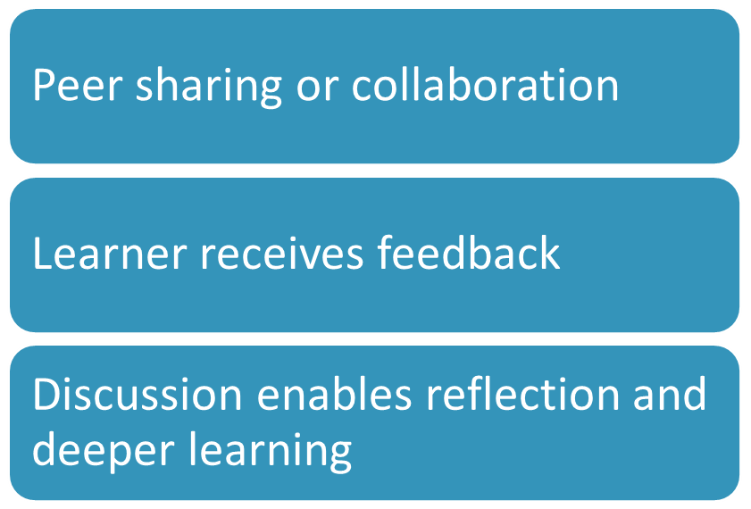
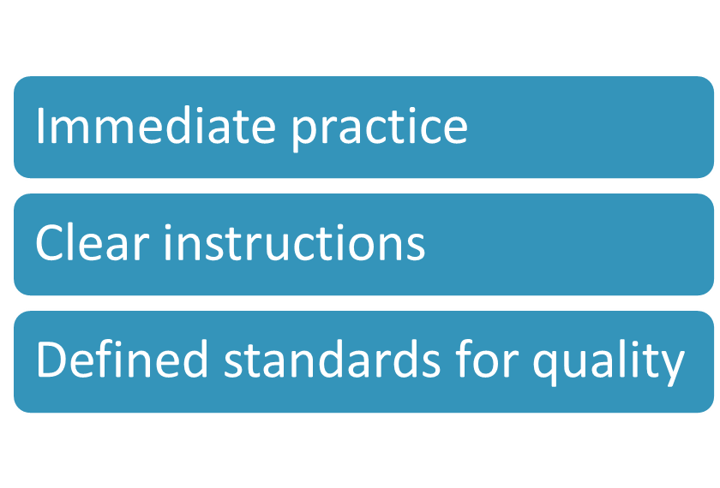
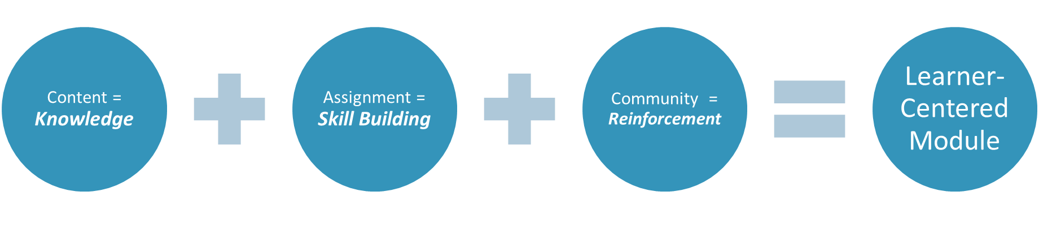
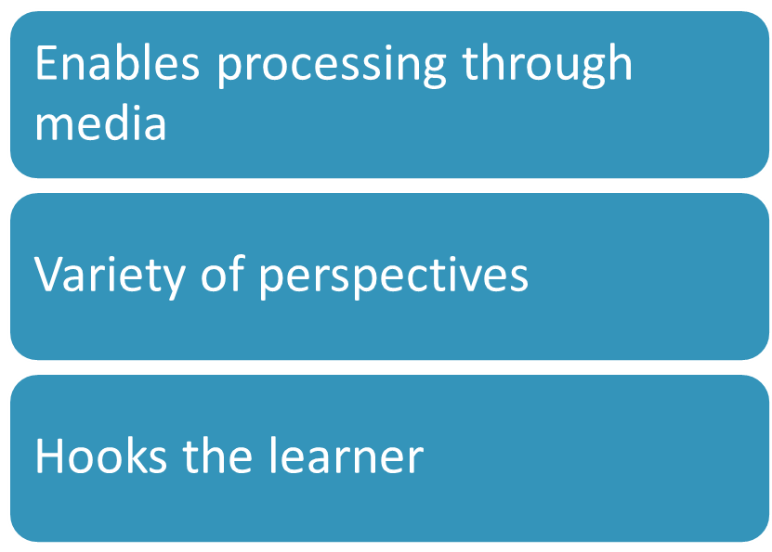

Content/Learn & Reflect
The phrase “content is king” is widely used in the marketing world, but it can refer to the eLearning as well. Do you know why?

- Content can help you build the authority of your training.
- Content can encourage learners’ engagement.
- Content can add value to your training.

So, how will you support your learners by providing them with learning resources? First, you'll have to make an important decision: "to create or to curate." Although creating your own content can often provide unique and specialized information for your learners, curating content from reputable sources can add richness and expertise to your courses quickly.

Read
How to Create Great Training Content (Optional, Article in eLearning Industry, 15 min)

Read
Why You Should Use Content Curation in your L+D Strategy (and How to Do It) (Article in Shift! 8 min)
Curating content is an effective way of mining information that makes relevant data readily available to learners. Learners are spared the need to hunt around for content or read through mountains of irrelevant information to find what they need.

Criteria for great content/Learn & Reflect
- Enable content processing through varied media (visual, text, audio) supporting different learning styles
- Incorporate a variety of perspectives/sources to encourage deeper understanding
- Hooks the learner to pique interest and grab attention

Assignments
In most teaching environments, assignments are utilized to have learners apply what they have learned in a deep or holistic way. In corporate training, we advocate that assignments focus on applying what is learned to real-world environments, as much as possible. Why is this? Because this conforms most closely to the principles of Andragogy.

Assignments can range from application of content to “real life examples,” crafting prototypes or examples, assessing knowledge through quizzes and exams, to project-based learning. The assignments for the course, for example, are the “Take Action” sections of this document, which is combined with the content (right here!) to lay the foundation.

Criteria for great assignments/transfer of learning activities:
- Provides opportunity for immediate practice/application of concepts
- Clearly stated instructions/process for completion
- Clearly defined standards of expected quality

NOTE: Assignments have their own special anatomy and writing style, which we’ll cover in Week 3. For right now, consider what the assignment would be – don’t worry about how you’ll deliver it yet.

Community
Research shows that the skills with the greatest impact on individual and organizational performance are best learned in concert with other people. For example, collaborative activities greatly increase a sense of responsibility in individual participants.
Assignments can range from application of content to “real life examples,” crafting prototypes or examples, assessing knowledge through quizzes and exams, to project-based learning. The assignments for the course, for example, are the “Take Action” sections of this document, which is combined with the content (right here!) to lay the foundation.

Criteria for great community/collaboration elements:
- Assignment effectively incorporates peer sharing or collaboration during creation process
- Learner receives feedback on submitted assignments from peers and/or experts
- Discussion enables deeper reflection and/or learning from peers and/or experts

Bookmark
Collaborative Learning (Cornell University, Center for Teaching Innovation website)
Fabulous resource that defines the benefits of Collaborative Learning, specific considerations, and recommendations for implementation. The Examples page is a treasure trove of great ideas!

Reflect (10 min)
Based on the article, there are many potential benefits of Collaborative Learning. Which of your learning objectives best lends itself to a collaborative approach?

Take Action: Build a Module, from the Brainstorm Up! (35–55 min)

- Module Map (5-10 min)
Instructions: Use this space to dump initial research, ideas, and information related to each of the three areas.
This is intended as a VERY high-level notes. If this doesn’t work for you, hop down to the next section.

Learning Objectives | Content | Assignment | Community
- Enter Learning Objective 1
- Enter Learning Objective 2
- Enter Learning Objective 3

- Adult Learning Theory Planning Tool (10–15 min)
Instructions: To ensure that we’re being intentional about a learner-centered practice, use a few moments to reflect on how you can strengthen your Module Map and bring the following into your planned activities:

- Keep Adult Learners Involved: You should try to give learners discretion to choose options, paths, or the topic of their assignments.
- Encourage Sharing of Experience: You should assume that learners may have relevant experience, and you can invite them to share their experiences; assignments should be broad enough for learners to apply their own experience to it.
- Make it Relevant and Impactful to Learners' Lives: You can ask learners to observe, reflect, try out, and apply concepts to a current challenge that they are facing.
- Keep it Problem-Centered: Keep the assignment focused on an authentic problem of reasonable scope (but allowing for nuance), and be more open-ended on the potential solutions.

Involve the Learner | Encourage Sharing of Experience
Make it Relevant & Impactful to Learners | Keep it Problem-Centered

- Content/Learn & Reflect Brainstorm (5-10 min)
Reminder: Criteria for great content/Learn & Reflect
- Enable content processing through varied media (visual, text, audio) supporting different learning styles
- Incorporate a variety of perspectives/sources to encourage deeper understanding
- Hooks the learner to pique interest and grab attention

Watch

Read

Bookmark

Listen

Reflect

Reflect (5 min)
Are the items above most appropriate for Prework, In-module instruction, or to accompany an assignment?

- Assignment Brainstorm (5-10 min)
Reminder: Criteria for great assignments/transfer of learning activities:
- Provides opportunity for immediate practice/application of concepts
- Clearly stated instructions/process for completion
- Clearly defined standards of expected quality

Reflect (5 min)
What are some ways for learners to immediately apply their content/course learning?

- Community Elements (5-10 min)
Reminder: Criteria for great community/collaboration elements:
- Assignment effectively incorporates peer sharing or collaboration during creation process
- Learner receives feedback on submitted assignments from peers and/or experts
- Discussion enables deeper reflection and/or learning from peers and/or experts

Reflect (5 min)
What are some ways for learners to immediately apply their content/course learning?

