Week 1 Handout: Basics of Learning Experience Design (LXD)

Part 1: LXD - Why, How, and What

Defining Learning Experience Design
Using the discussion and your Prework Learn/Reflect content, what would you say are the defining characteristics of Learning Experience Design?

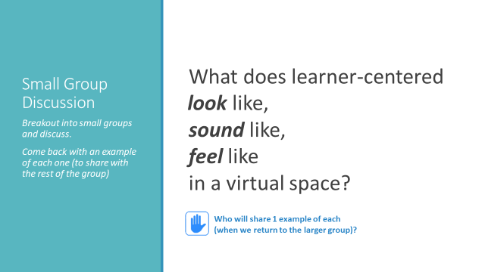
WHY: Learners are at the Center
Looks like | Sounds Like | Feels Like

Ultimately, Learner-Centered is about ______________________
- to the
- to the
- to the
- to the
- to the

HOW: The A.D.D.I.E. Model of Instructional Design
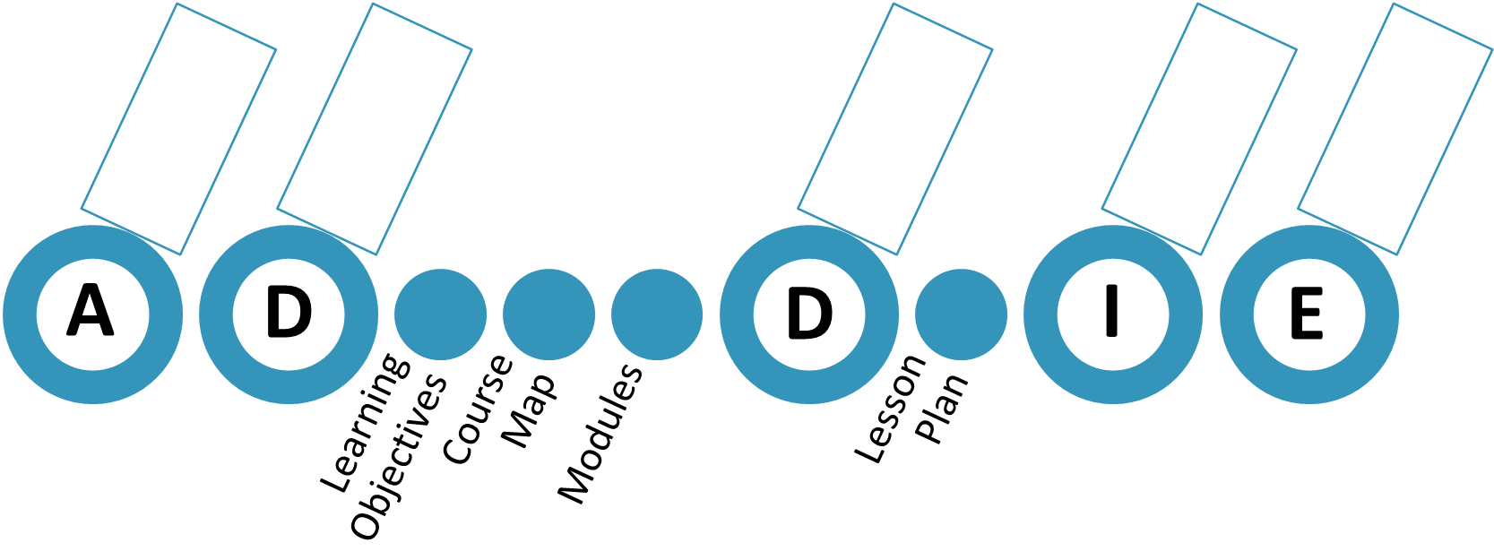

WHAT: Learning Experience Design Elements & Rubric
The Purpose of a Design Rubric?

