Week 2 Handout: Basics of Learning Experience Design (LXD)

Designing for Learner

Learning Objectives Reflection
How did the quality and quantity of your learning objectives change when you applied the resources in the Learning Objective Builder?

Where in Bloom’s Taxonomy are each of your Learning Objectives? Will that level of learning get learners where they need to be?

How well do you self-score on each of your Learning Objectives? Where do you need help/guidance/advice?
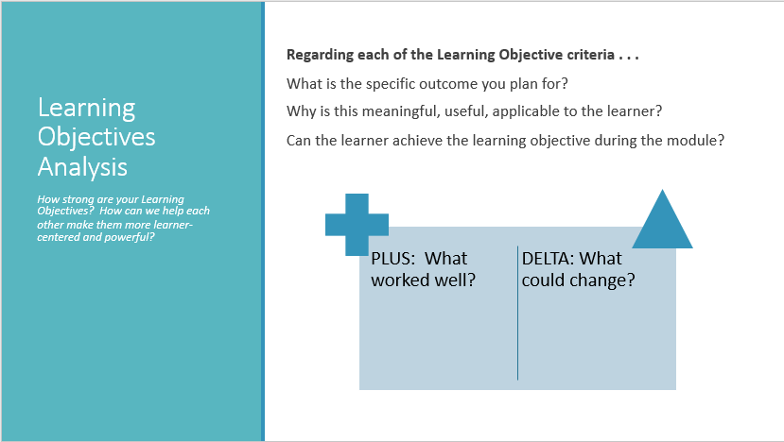

Designing for Learner: Modular Learning
What is a module?

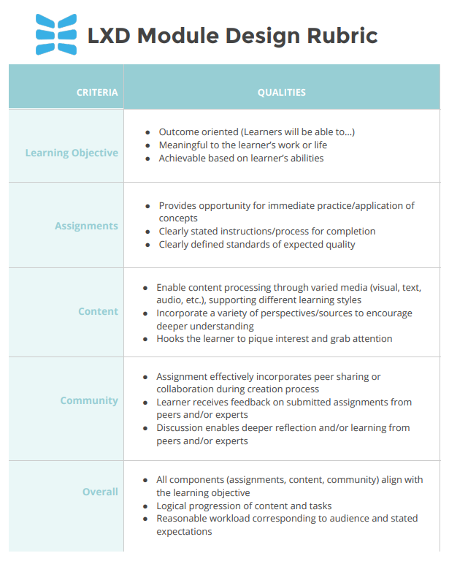

PURPOSE

- Content/Learn & Reflect
Key Question: What prework or information-sharing will you need to incorporate, in order to ensure that learners have baseline knowledge for building off of?

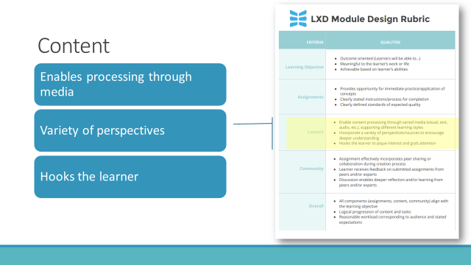
Criteria for great content/Learn & Reflect
- Enable content processing through varied media (visual, text, audio)
- Incorporate a variety of perspectives/sources to encourage deeper understanding
- Hooks the learner to pique interest and grab attention

Watch
Read
Bookmark
Listen
- Assignment
Here’s where you sketch out the activities that help learners DO the learning.
Key Question: What activities will get them to USE Bloom’s Taxonomy (your driving verb of Learning Objectives)?
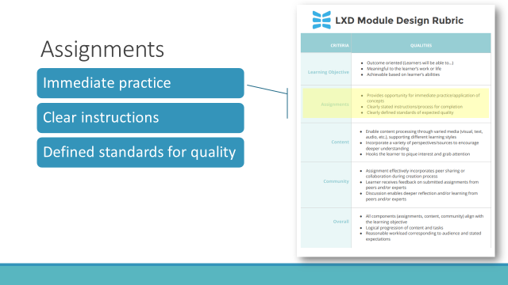
Criteria for great assignments/transfer of learning activities:
- Provides opportunity for immediate practice/application of concepts
- Clearly stated instructions/process for completion
- Clearly defined standards of expected quality

- Community Elements
Research shows that the skills with the greatest impact on individual and organizational performance are best learned in concert with other people. For example, collaborative activities greatly increase a sense of responsibility in individual participants.

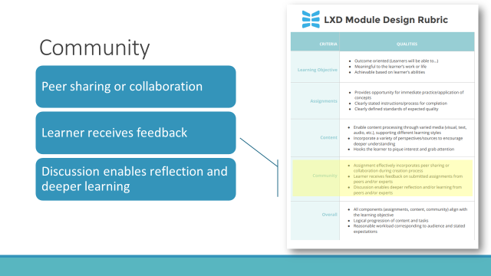
Key Question: How can collaboration enhance the learning experience for participants? Sharing, discussion, providing feedback, leading discussion, teaching others, reflection activities all help cement the learning
Criteria for great community/collaboration elements:
- Assignment effectively incorporates peer sharing or collaboration during creation process
- Learner receives feedback on submitted assignments from peers and/or experts
- Discussion enables deeper reflection and/or learning from peers and/or experts

Designing for Facilitator: Lesson Plan Tools
Anatomy of a Lesson Plan
HOW
WHO/WHERE
WHAT
WHEN

 | Instructor Lead Training (ILT) | Time Allotted | Virtual Instructor Training Content  (VILT) | Delivery  Method | Materials Needed
 | If you have taught the course previously, use it as the basis for “adjusting” | How many minutes will it take to complete? | How will this be delivered in a live, synchronous, virtual setting? | What technology is required in order to deliver? Be specific (ex. polls, breakout groups, direct instruction, chat) | What visuals and materials can enhance the course?  - Handouts  - Slides  - Audio, Video  - Screen Share
Introduction & Welcome |  |  | Tip: Here’s a great formula for remembering to do all you need to do at the beginning of a lesson:  1. Welcome everyone to the training  2. Hook them with a fact, a story, or a compelling experience  3. Get clear on group agreements  4. Preview the handouts/technology  5. Introduce yourself as their guide
Learning Objective 1  Enter the full learning objective here | Tip: use this as inspiration but don’t get stuck in the “old way” | Tip: Do this last | Tip: Phrase this as the action the Facilitator should take  Tip: Organize as Topic/Item:  • Bullet Point  - Bullet Point | Tip: Phrase this as the action the Facilitator should take | Tip: Hyperlink the document  Tip: Use specific document titles
Learning Objective 2  Ex. Given the definitions and characteristics of leadership and management, learners will be able to categorize activities | Leadership vs. Management characteristics  Sorting Activity at tables of 4  Discussion in large group | 50 min | Define Leadership  - Influence, Guide, Group, Inspiring  - What makes the diff  Characteristics of:  Leadership  Management  Sorting Activity  Discussion: Middle Pile | Facilitator overview  Scrumblr app w/  Zoom Breakouts  Large Group | Leadership Definition SLIDE  Characteristics  SLIDE  6 Scrumblr URLS  Instructions SLIDE  Middle Pile Q SLIDE
Learning Objective 3
Enter the full learning objective here
Wrap Up and Take it Home |  |  | Tip: Here’s a great formula for remembering to do all you need to do at the end of a lesson:  1. Key Takeaways. Elicit: What were some of the main discussion points? So what? Now what?  2. Invitation to Share Feedback.  3. Join us in future courses and events  4. Stay in contact and thank you for coming

Notes

