Designing for Facilitator: Lesson Plans

Going Beyond the Outline
Facilitators have a lot to juggle, especially when presenting in a virtual environment and managing asynchronous content, assignments, and collaborative learning activities.

While writing a Lesson Plan can be time consuming, the overall time savings can be greatly beneficial to the busy Learning Experience Designer. Perhaps more importantly, the Lesson Plan is an organization tool that also ensures the module meets your overall course criteria. When content, assignments, and collaborative learning align with learning objectives, the course flows logically, and the workload is reasonable for the course - - that’s learner-centered.

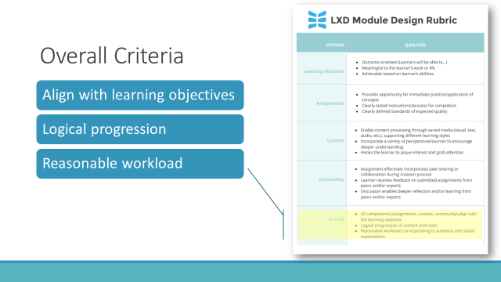

Reflect (5 min)
What are the purposes of each of the following elements of the Lesson Plan?

Column Headers
Instructor-led Training =
Time Allotted =
Virtual Instructor-Led Training Content =
Delivery Method =
Materials Needed =

Row Headers
Introduction and Welcome =
Learning Objectives (1, 2, 3) =
Wrap Up and Take it Home=

Take Action: Create a Lesson Plan (20 - 30 min)
Instructions: Use the Lesson Plan One Sheet to guide your development of those outstanding Brainstorm ideas from above into a working Lesson Plan. Focus your attention on turning your Learning Objectives into Content and Delivery Method. That’s the hardest part! If you have time to work on the Intro/Wrap up, awesome. If you can map out the Materials Needed and Time Allotted, bravo.

Prework:

Lesson Plan:

 | Instructor Led Training (ILT) | Time Allotted | Virtual Instructor Training Content  (VILT) | Delivery  Method | Materials Needed
 | If you have taught the course previously, use it as the basis for “adjusting” | How many minutes will it take to complete? | How will this be delivered in a live, synchronous, virtual setting? | What technology is required in order to deliver? Be specific (ex. polls, breakout groups, direct instruction, chat) | What visuals and materials can enhance the course?  - Handouts  - Slides  - Audio, Video  - Screen Share
Introduction & Welcome

Learning Objective 1
Enter the full learning objective here

Learning Objective 2
Enter the full learning objective here

Learning Objective 3
Enter the full learning objective here

Wrap Up and Take it Home

