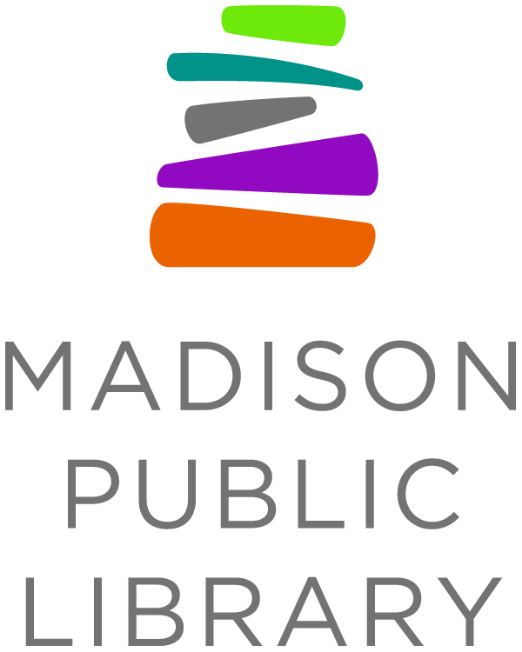
For Immediate Release: January 7, 2021
Library Contact: Tana Elias, Digital Services & Marketing Manager, Madison Public Library, 608-225-0619, telias@madisonpubliclibrary.org
Madison Public Library Receives $1,000 from University of Wisconsin-Madison for East Asia in Wisconsin Library Program, Adds 50+ Cookbooks to Collection
MADISON, WI - Madison Public Library has added more than 50 new cookbook titles to the collection thanks to a recent $1,000 grant from the University of Wisconsin-Madison’s Center for East Asian Studies’ (CEAS) East Asia in Wisconsin Library Program.
The list of new cookbooks focuses on food from China, Hong Kong, Japan, Korea, Taiwan and Tibet. The titles for the grant were selected to increase cultural perspective and raise awareness about the history, food systems, indigenous ingredients, unique cooking practices and ancestral and modern food traditions and recipes of East Asian culture in Madison. The cookbooks were purchased in November when Madison Public Library was notified of the grant award, and all of the cookbooks have now arrived at the library and will be available for checkout.
“Fostering respect for the great variety of food in East Asian culture helps develop an appreciation for what makes people different. The diversity in nutrition, tastes, and presentation bring greater understanding and join people together to recognize and communicate with food,” said Madison Public Library Collections Manager Molly Warren.
CEAS created the East Asia in Wisconsin Library Program to encourage Wisconsin libraries to augment their collections with East Asia-related materials. CEAS partnered with the Wisconsin Department of Public Instruction, the Wisconsin Library Association, and the Cooperative Children’s Book Center to plan and promote the program. Madison Public Library’s grant was one of 38 awarded to libraries across Wisconsin, totaling $32,765 in awards.
Estimates indicate 9% of the Madison population is Asian, but only 2% of the cookbook collection at Madison Public Library falls into the category of Asian Cooking.
“As part of its vision, Madison Public Library provides free and equitable access to cultural and educational experiences. The library celebrates ideas, promotes creativity, connects people, and enriches lives,” said Warren. “A focus on food pairs Madison Public Library’s mission and vision with the core mission of this grant opportunity to foster a better understanding of East Asia and its peoples.”
A second round of funding for the East Asia in Wisconsin Library Program is planned for release in the fall of 2021.
About Madison Public Library
Madison Public Library’s tradition of promoting education, literacy and community involvement has enriched the City of Madison for more than 145 years. Visit the library online at www.madisonpubliclibrary.org, madisonpubliclibrary on Facebook, @madisonlibrary on Twitter, or @madisonpubliclibrary on Instagram.
About the Center for East Asian Studies
The Center for East Asian Studies (CEAS) is the focal point connecting East Asia to the University of Wisconsin-Madison. One of the UW-Madison’s eight federally funded area studies National Resource Centers, CEAS is dedicated to all aspects of research, education and outreach related to China, Japan, and Korea.

