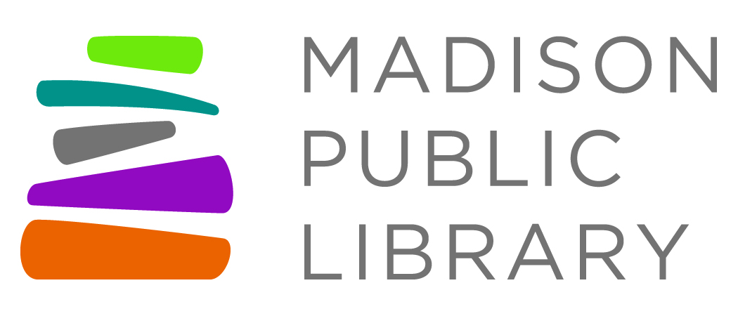
For Immediate Release: July 20, 2021

Friends Contact: Tom DeChant, President, Friends of Goodman South Madison Library, 608-255-6595, tdmadtown@charter.net
Library Contact: Tana Elias, Digital Services & Marketing Manager,
Madison Public Library, 608-266-4953, telias@madisonpubliclibrary.org
Friends of Madison Public Library Host Warehouse Clearance Sale
Six library Friends' groups are pooling their inventory for a large sale of gently used and donated books. The sale takes place Saturday, August 7, 2021, 9am-4pm, rain or shine, at the Madison Public Library Service & Support Center at 1301 W. Badger Road in Madison. All proceeds benefit Madison Public Libraries.
“This is the first sale we’ve held since the pandemic,” said Tom DeChant, President of Friends of Goodman South Madison Library. “Our groups pooled resources and worked together to offer one huge warehouse sale to local book lovers, with great prices and a food cart on-site for lunch-time shoppers to enjoy.”
Sale items will be replenished throughout the day, and there will be a bag sale from 3-4pm for $5 per bag. Friends accept cash, check or credit card payment.
Prices include:
- hardbound books $2
- paperback books $1
- children's hardbound books $1
- children's paperback and board books $.50
- CDS, DVDs, and audiobooks on CD $1
Participating Friends' groups include those for the Central, Goodman South Madison, Hawthorne, Lakeview, Meadowridge, and Monroe Street libraries. Interested people can also learn more about becoming Friends’ members or volunteering at the sale.
More information at madpl.org/book-sales

About Madison Public Library
Madison Public Library’s tradition of promoting education, literacy and community involvement has enriched the City of Madison for more than 145 years. Visit the library online at www.madisonpubliclibrary.org, madisonpubliclibrary on Facebook, @madisonlibrary on Twitter, or @madisonpubliclibrary on Instagram.

About Friends’ groups
Each Madison library has a Friends group consisting of volunteers and members who support the activities at their library through book sales, bake sales, volunteering in the library and through advocacy work. Friends groups have existed since 1965.

